Cover Page

Table of Contents

I. Getting Started 2

a. Logging In 2

II. Features: File Maintenance 4

a. Account Type 4

b. Share Capital Setup 5

c. Time Deposit Matrix 5

d. Interest Rates 6

e. Fiscal Year 6

f. OR Management 7

g. Company Profile 7

h. Signatories 8

i. Users 8

j. User Rights 9

k. System Lock 9

III. HR / Payroll 10

a. HR / Master Files 10

b. HR / Employee 12

c. Payroll / Setup Payroll 14

d. Payroll / Employee Deductions 16

e. Payroll / Employee Benefits 17

f. Payroll / Payroll Entry 17

g. Payroll / Post SL Payroll Deductions 18

h. Payroll / Payroll Reports 18

IV. Financials 20

a. Setup 20

b. Chart of Accounts 21

c. Assets 21

d. Financial Reports 22

e. Statement of Accounts 30

# Getting Started

## Logging In

1. From your desktop view or anywhere you have saved the application, look for the application “CITCS - COOP Information System” and open it.

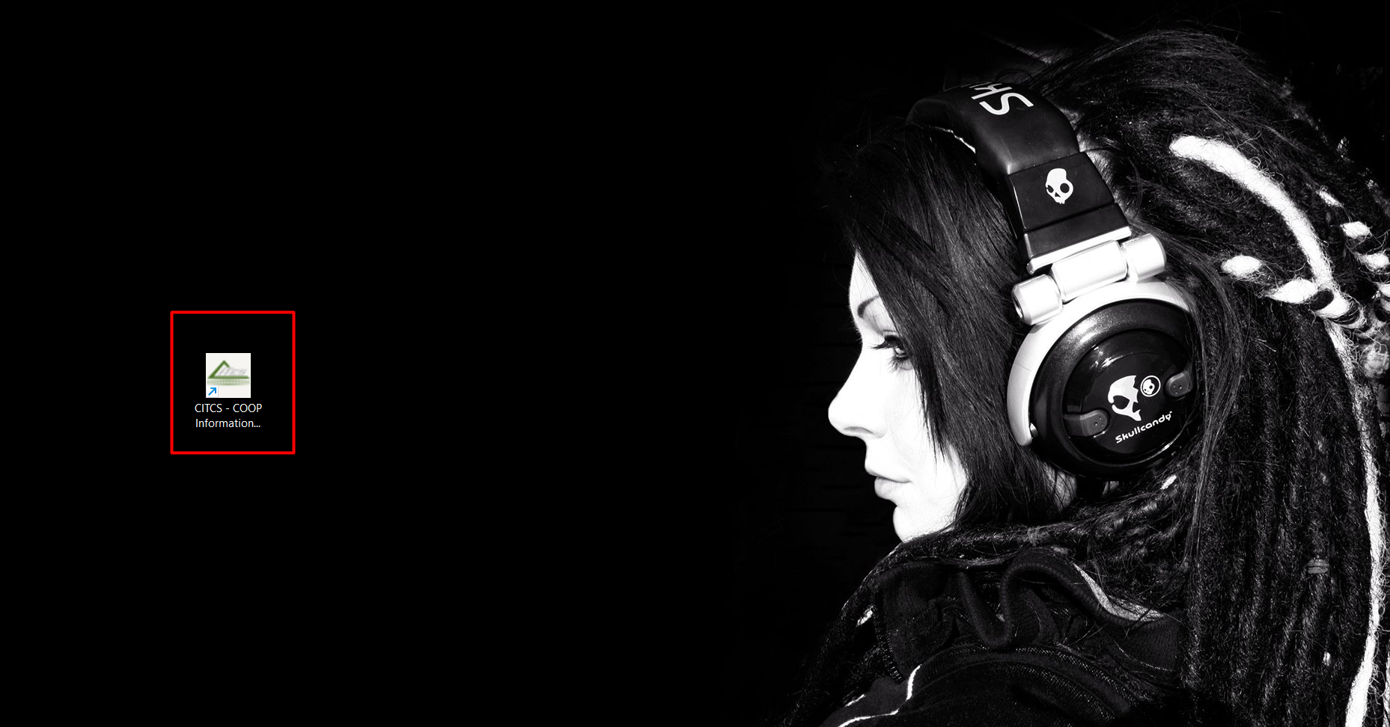

1. You will see a loading screen and wait for the loading screen to finish and you will be redirected to login your credentials.

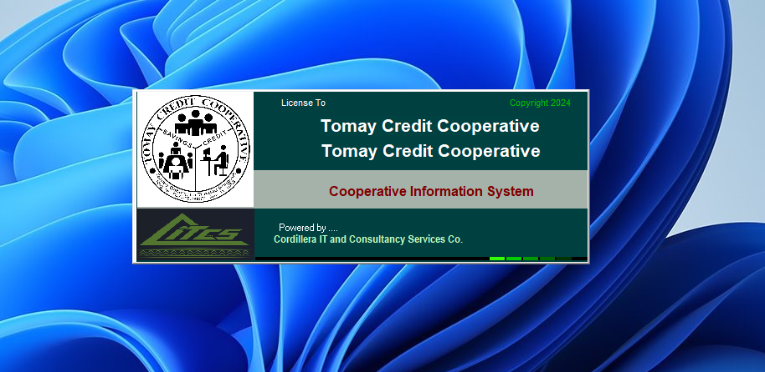

1. User Login

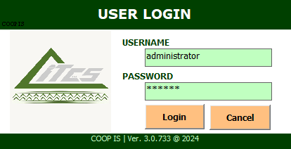

1. After logging in your credentials, you will be redirected to the landing page of the application shown below.

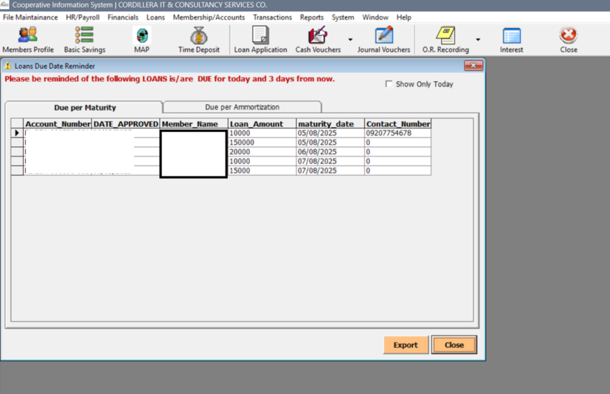

# Features: File Maintenance

* This feature includes the modifications and alterations mostly on the functionalities and libraries of the System. The sub module or features under the File Maintenance tab are the following: Account Type, Share Capital Setup, Time Deposit Matrix, Interest Rates, Fiscal Year, OR Management, Company Profile, Signatories, Users, User Rights, and System Lock.

## Account Type

* This interface allows users to manage various account types within a cooperative system. It provides tools to add, edit, delete, and save account types, each defined by attributes like account code, description, and associated GL accounts. Users can also configure options such as visibility in official receipts, withdrawal eligibility, and interest computation inclusion.

1. From your application window, you will see a button on the upper-left most part of the screen File Maintenance tab. Upon clicking, you will see a window like shown below.

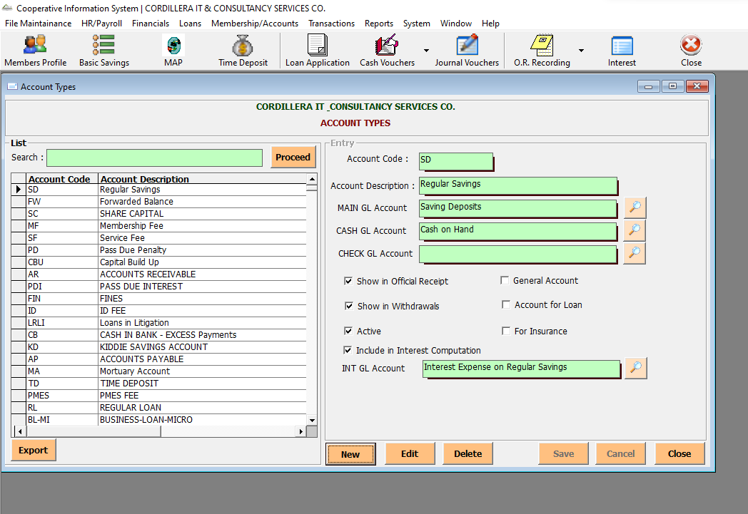

1. Sample screenshot upon clicking the search icon button (Wrong screenshot—to change upon opening in Wangal)

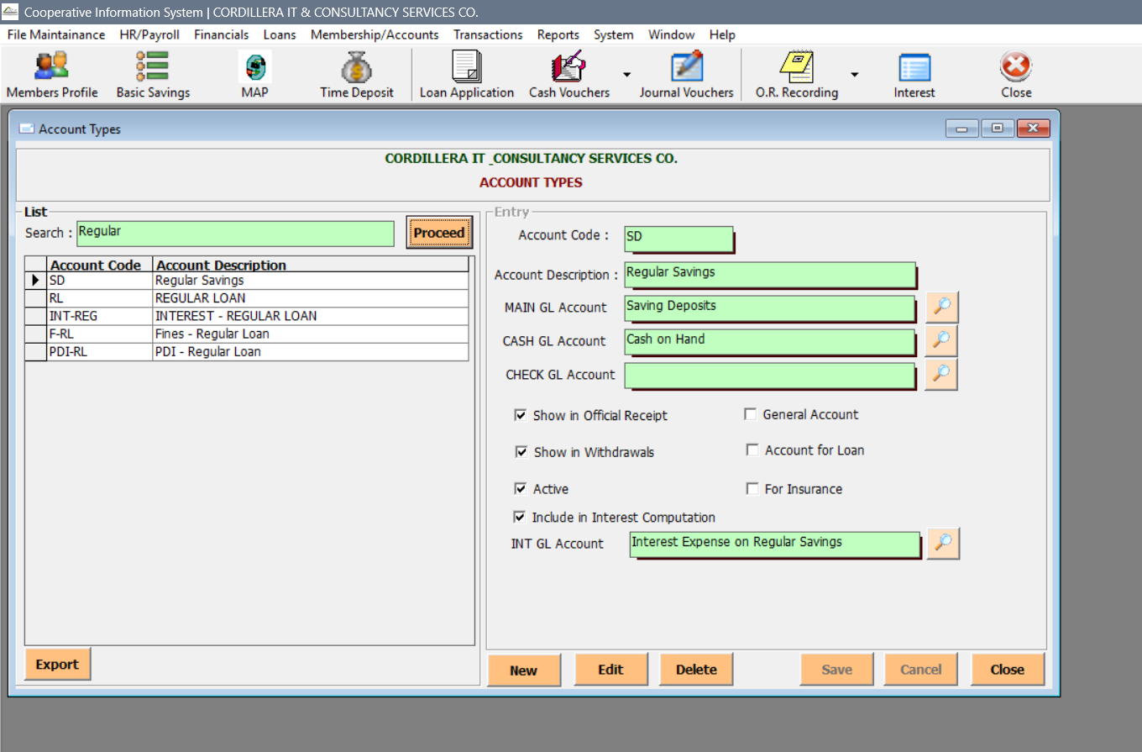

## Share Capital Setup

* This module allows users to configure share capital details for cooperative members.The setup ensures accurate tracking of member investments and supports cooperative financial operations. Users can save or close the setup using the provided buttons.

1. You can also setup you Share Capital in the File Maintenance tab and clicking the File Maintenance Setup.

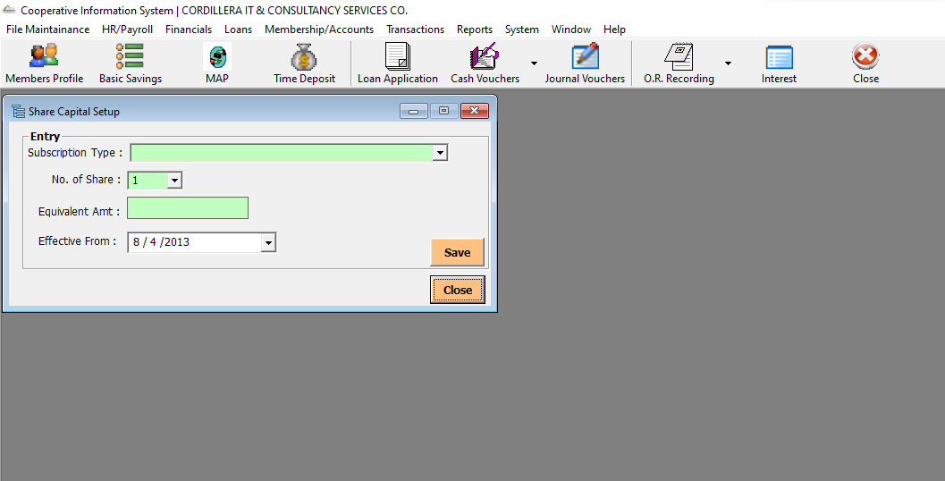

## Time Deposit Matrix

* This module enables cooperatives to define and manage time deposit schemes. The matrix helps categorize deposits based on value and duration, ensuring accurate interest computation and financial planning. It includes options to add, edit, delete, and export entries for streamlined maintenance.

1. Setting up for Time Deposit Matrix can also be found in the File Maintenance tab and clicking the Time Deposit Matrix

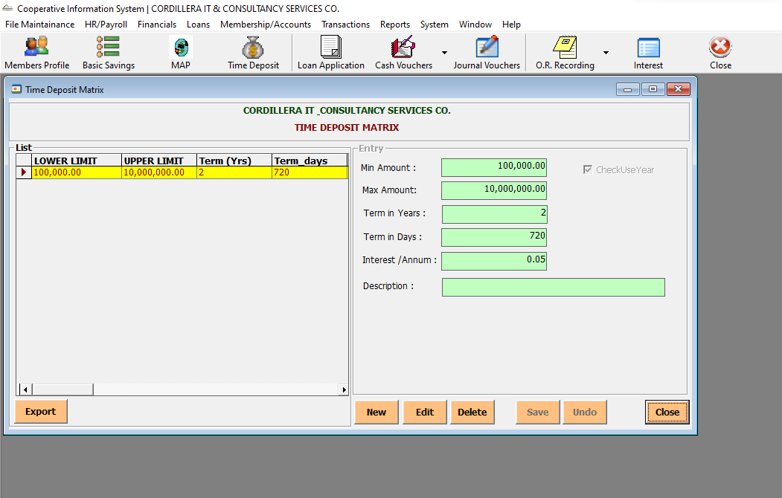

## Interest Rates

* This module allows cooperatives to configure interest parameters for various savings account types.It also links to relevant general ledger accounts and includes options for handling dormant accounts. The setup ensures accurate and automated interest computation across member accounts.

1. You can set up and update Interest Rates in the File Maintenance Tab and clicking the Interest Rates

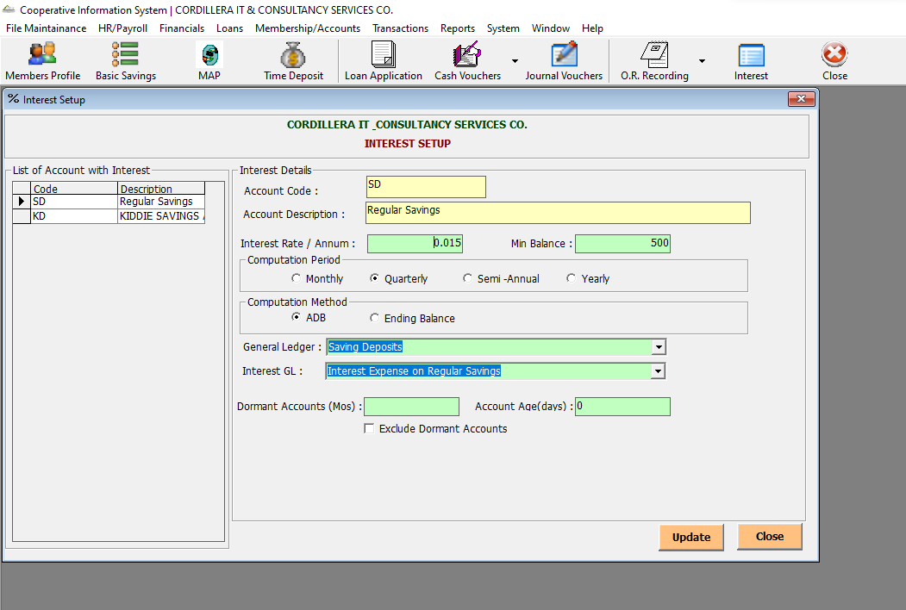

## Fiscal Year

* This module allows administrators to define and manage fiscal year periods for financial reporting.The option to set a default fiscal year ensures consistency across transactions and reports. The interface supports creating, editing, deleting, and saving fiscal year entries, streamlining financial period management.

1. You can set up and update Fiscal Year in the File Maintenance Tab and clicking the Interest Rates

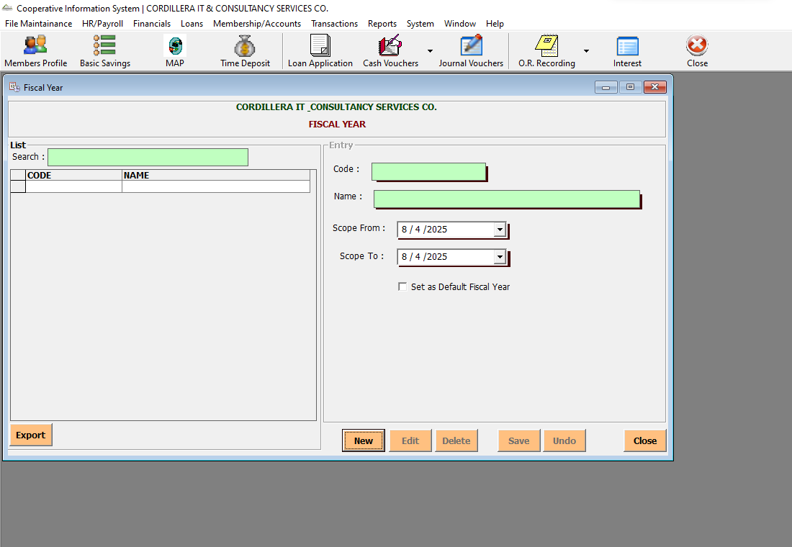

## OR Management

* This module facilitates the issuance and tracking of official receipts within the cooperative system.It includes a searchable user database to associate receipts with specific members. The interface supports saving, exporting, and listing issued receipts, ensuring accurate documentation and streamlined financial auditing.

1. Setting up for the OR Management can be found in the File Maintenance tab clicking the OR Management. You can also search in order to fill out related fields by clicking the search icon.

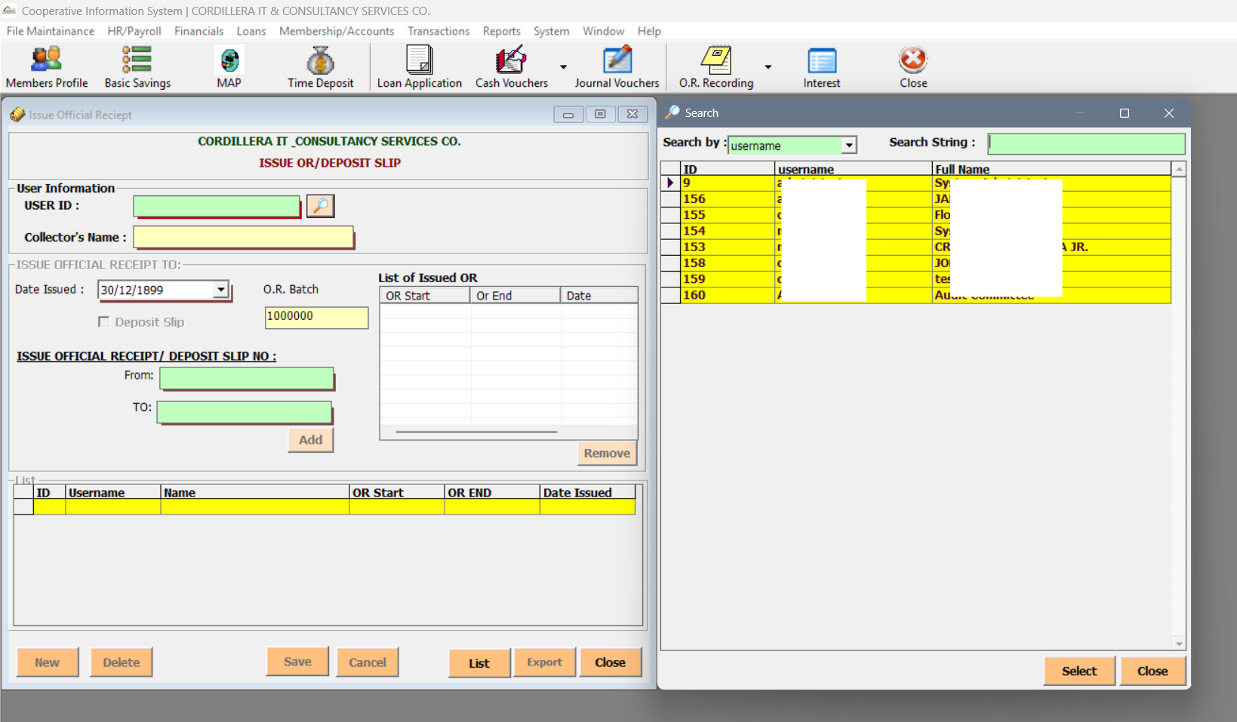

## Company Profile

* This module centralizes key cooperative information for system-wide configuration. It captures company details (name, address, CDA registration), account types (e.g., savings, share capital, medical fund), and system validations (e.g., PMES requirement, minimum balances).This setup ensures regulatory compliance, and customized document formatting.

1. You can set up and update Fiscal Year in the File Maintenance Tab and clicking the Company Profile

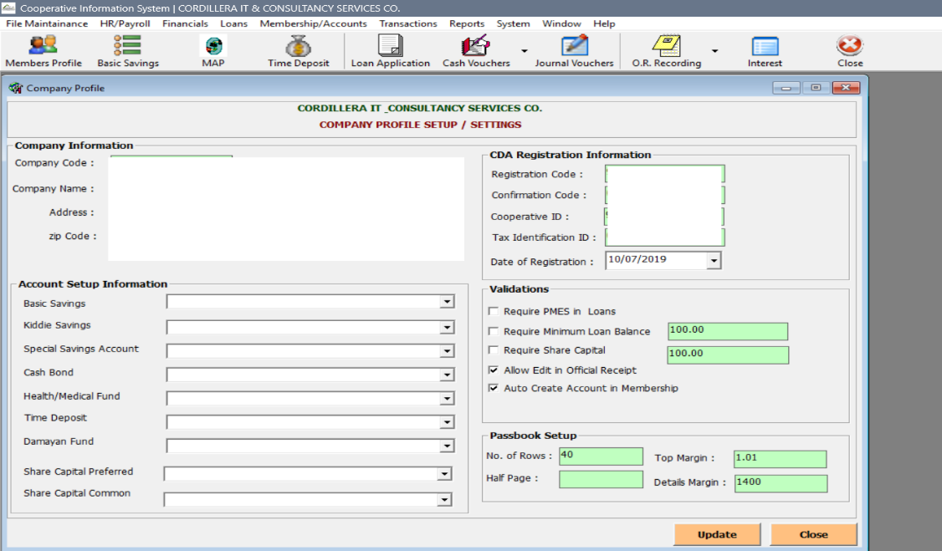

## Signatories

* Users can assign signatories to specific account types and link them to employee records. It supports updating, exporting, and refreshing signatory lists, ensuring accountability and proper authorization across cooperative operations.

1. In order to update and set up set of Signatories, you can do that by clicking the Signatories in the File Maintenance tab.

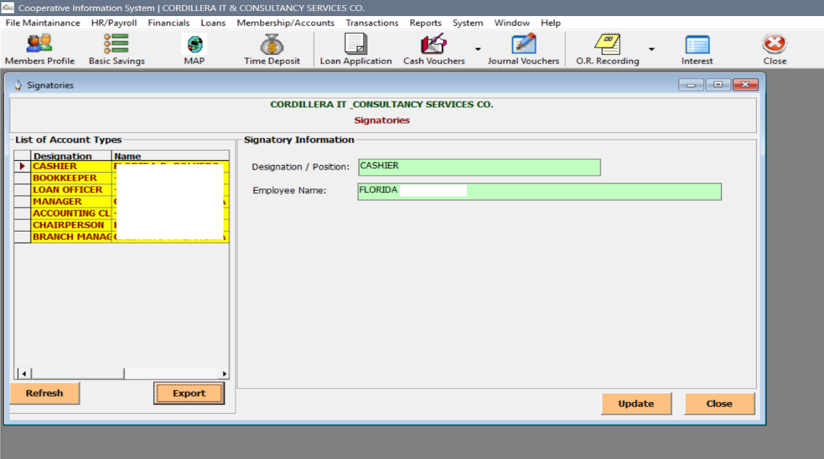

## Users

* This module handles the creation, modification, and permission settings of system users. It displays a list of existing users with their usernames, full names, and positions. Permission checkboxes enable fine-grained control over actions like OR overrides, TR validation, approval rights, and view-only access. The interface supports adding, editing, deleting, and saving user records, ensuring secure and role-based system access.

1. You can view set of users for File Maintenance in the Users.

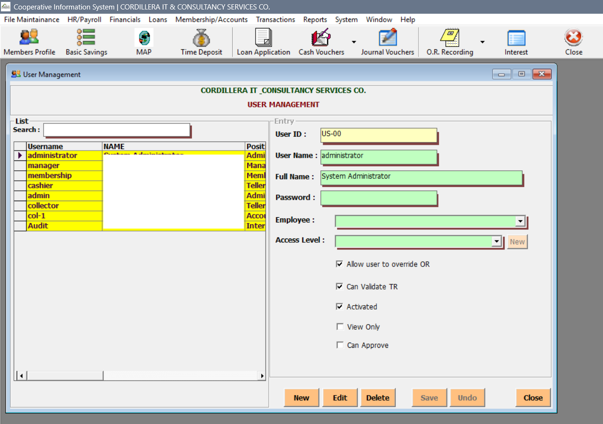

## User Rights

* This module controls access privileges across system modules based on user roles.This module controls access privileges across system modules based on user roles.

1. You can also update User Rights under the File Maintenance Tab. A search icon is also available to help you filter needed inputs in the fields.

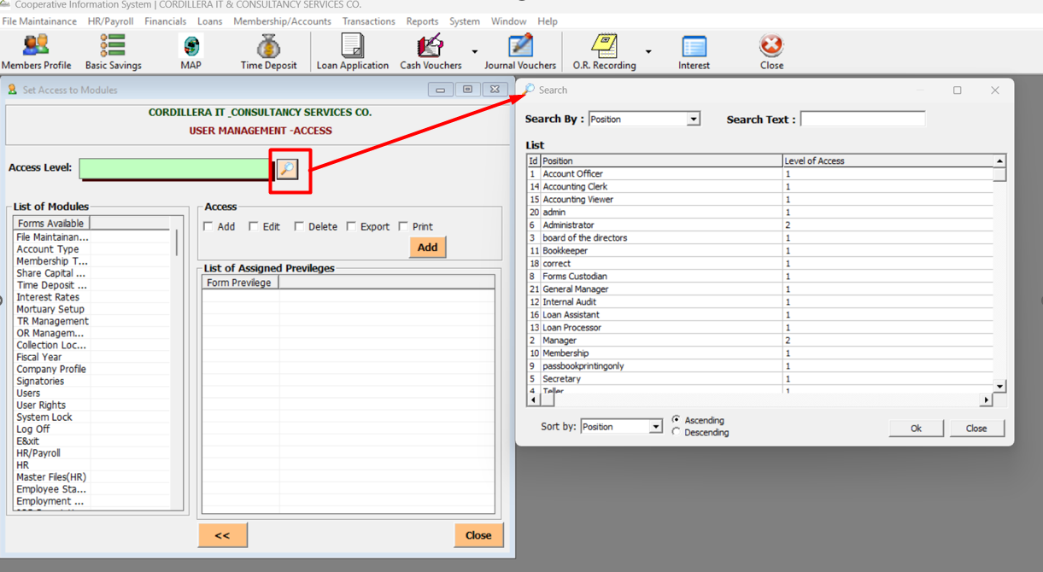

## System Lock

* This feature secures system access by enforcing login credentials before any operations can be performed. It displays a login window requiring a valid username and password**.**

1. You can lock your logged in user account to prevent unauthorize input of pertinent data in the system using your account under the File Maintenance tab.

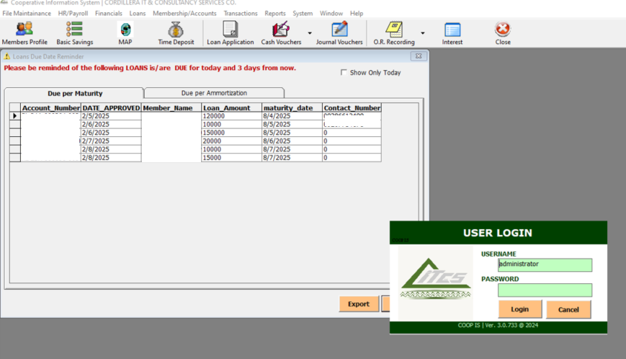

# HR / Payroll

* The HR / Payroll tab is divided into two respectively, The HR and the Payroll. Under the HR are the following features: Master Files and Employee. While on the other hand, Payroll features: Setup Payroll, Employee Deductions, Employee Benefits, Payroll Entry, Post SL Payroll Deductions, and Payroll Reports.

## HR / Master Files

* This module has four sub-modules having the following: Employee Status, Employee Type, Job Description and Holidays. These sub-modules help define core HR data for accurate employee management.

1. Employee Status – Its purpose is to categorize employees by their current standing and used for filtering employee records and determining payroll eligibility.

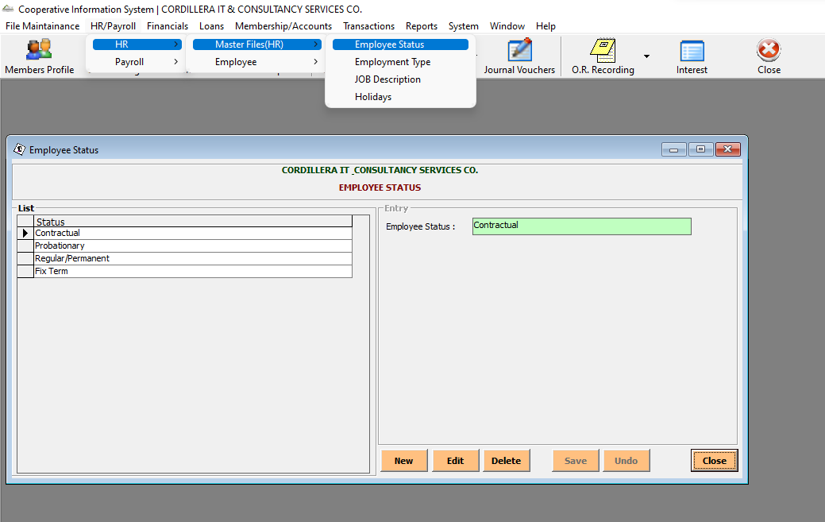

1. Employment Type - Defines the nature of employment

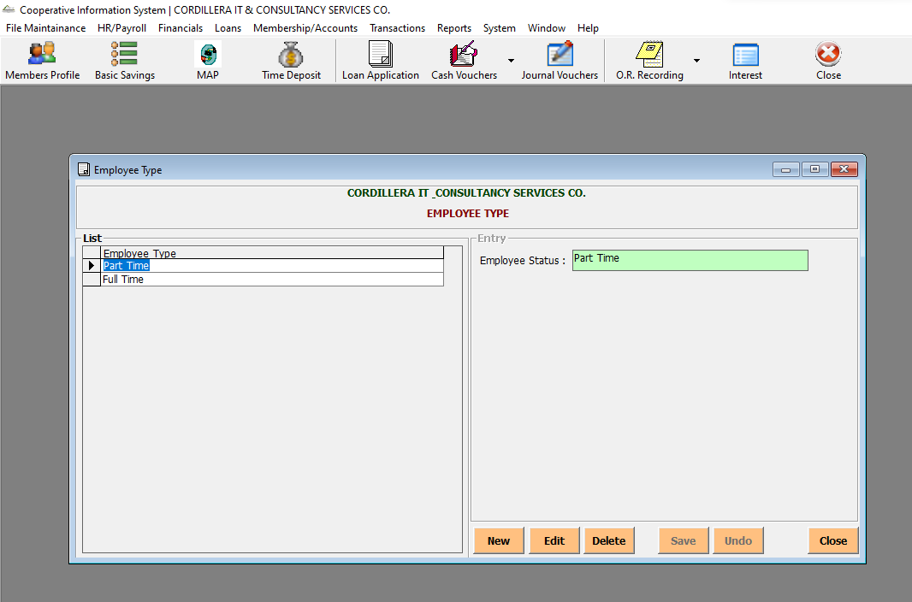

1. Job Description - Stores job titles and their corresponding responsibilities. Supports organizational clarity and role-based access or evaluation.

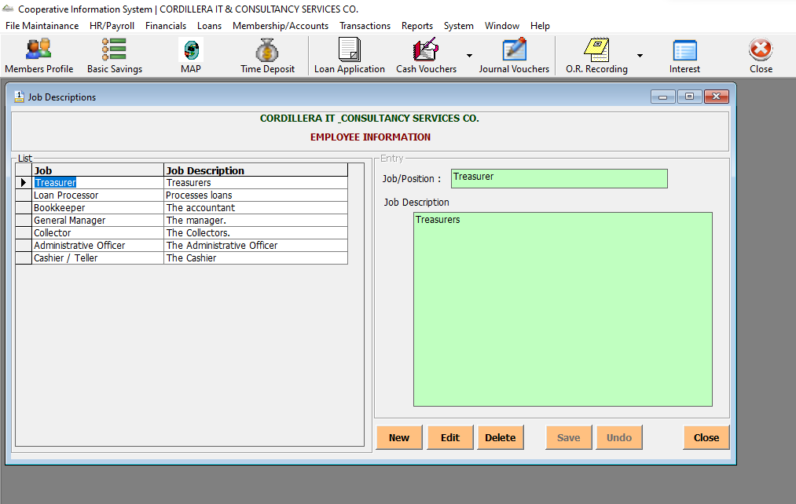

1. Holidays – Maintains a list of official holidays for payroll and attendance tracking.

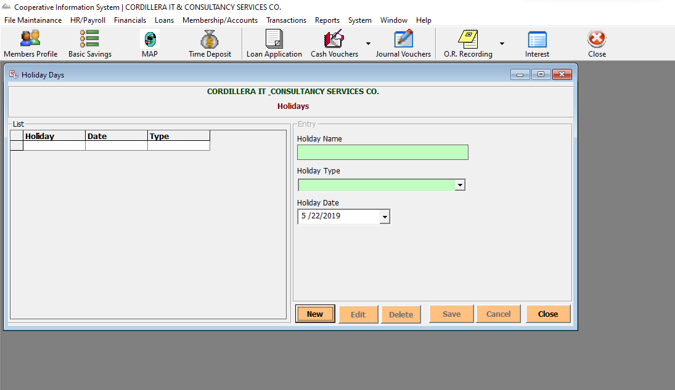

## HR / Employee

* The interface supports adding, editing, deleting, and saving employee records, ensuring accurate and up-to-date personnel data across the cooperative system.The interface supports adding, editing, deleting, and saving employee records, ensuring accurate and up-to-date personnel data across the cooperative system. **It also includes Service Record tab which** allows HR personnel to manage and document an employee’s service history.

1. Upon clicking the HR / Payroll tab, user will find under HR the Employee which you can choose Basic Information (201).

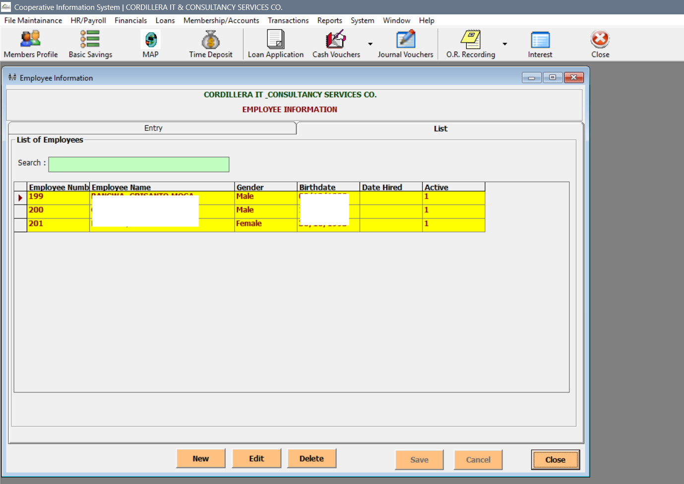

1. When the user clicks the new button, it activates the form fields to allow entry of a new employee's details. The form becomes editable, enabling HR personnel to input and save a new employee record.

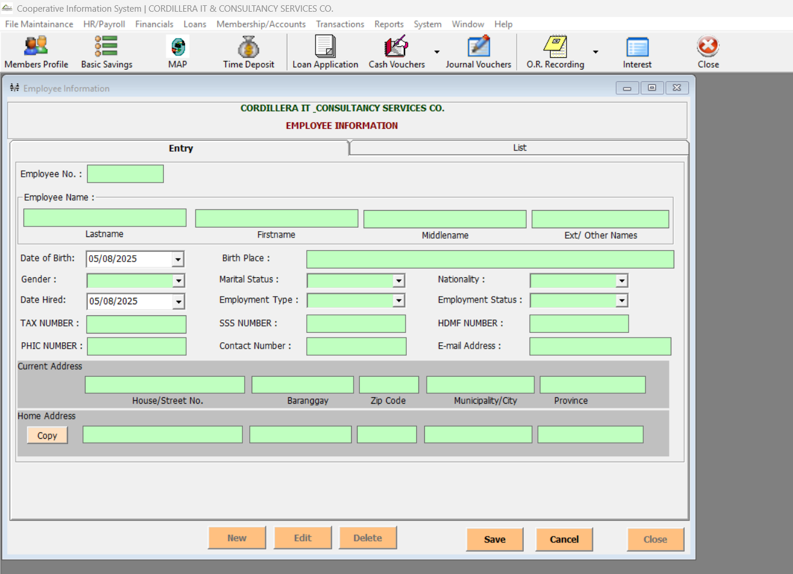

1. Upon clicking the HR / Payroll tab, user will find under HR the Employee which will you can choose Service Record.

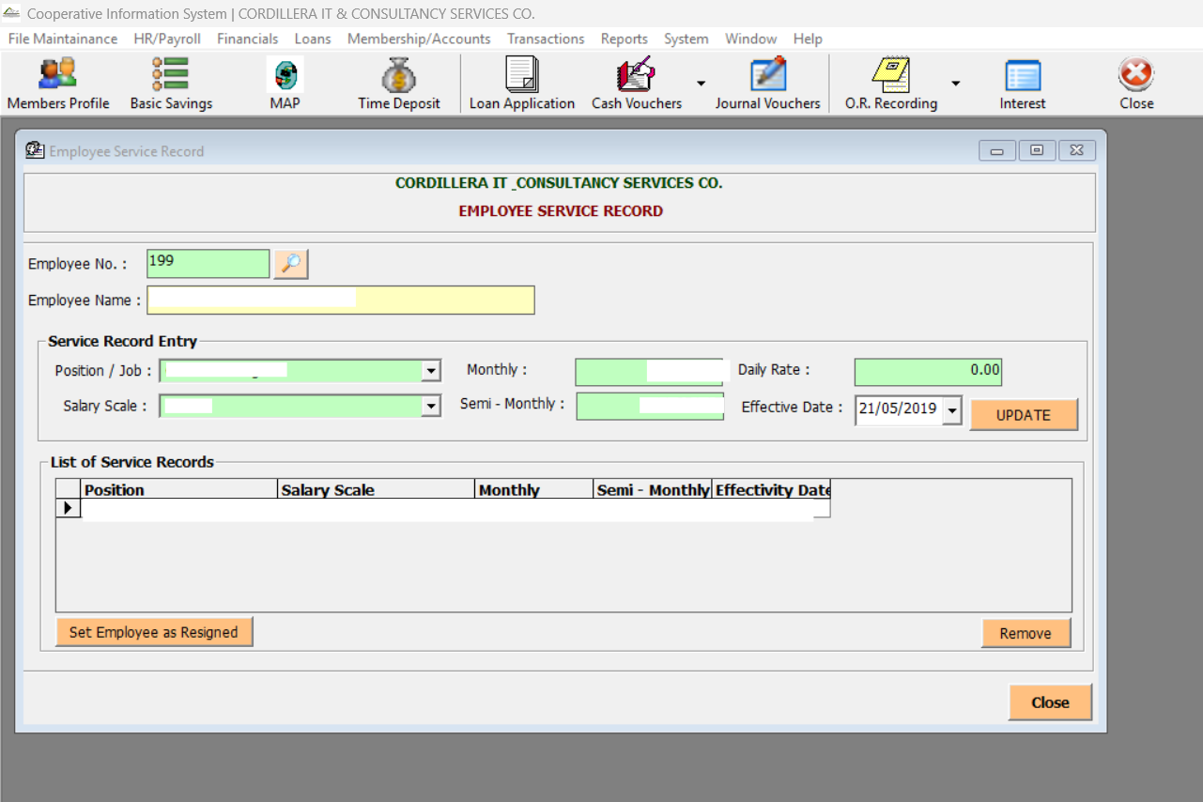

1. Sample screenshot of window if the employee is set as resigned.

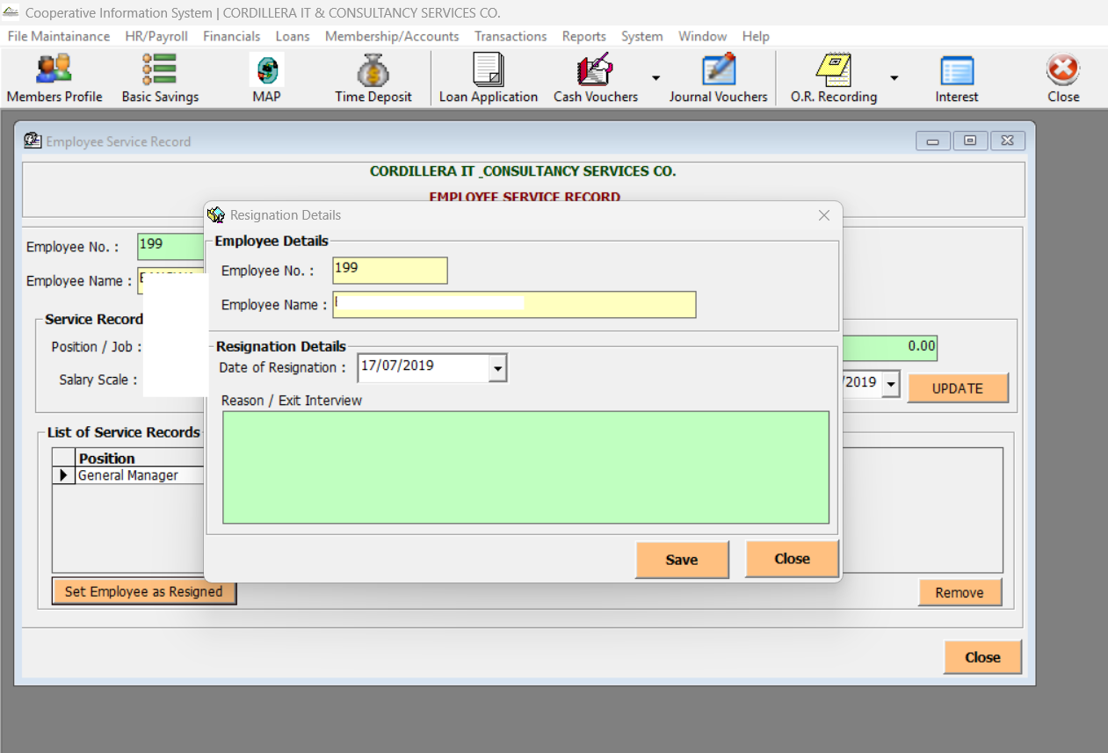

## Payroll / Setup Payroll

* This section configures key payroll components to ensure accurate salary computation and statutory compliance. It contains sub buttons namely: Payroll Periods, Payroll deductions, Payroll Benefits, Salary Scale, SSS Table and these are the screenshots.

1. Payroll Periods - This section defines the timeframes for salary computation and disbursement.

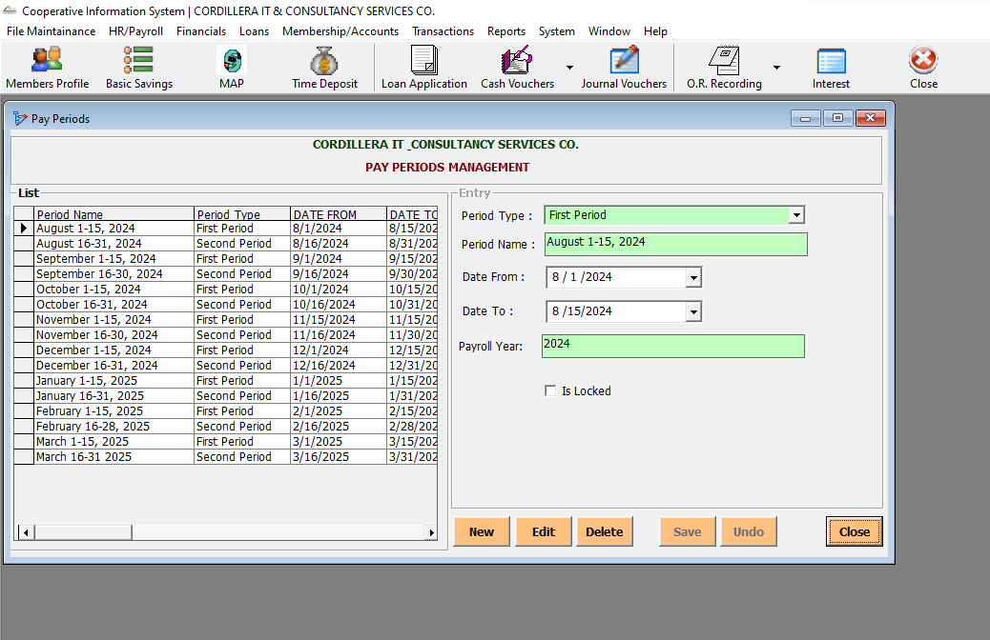

1. Payroll Deductions - This section manages all deduction types applied to employee salaries, both statutory and voluntary.

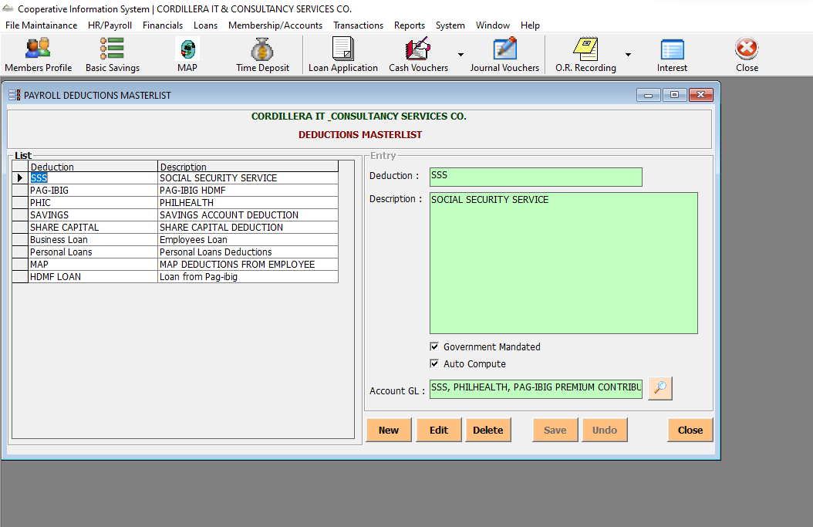

1. Payroll Benefits - This section manages non-salary compensation provided to employees, which may be taxable or non-taxable.

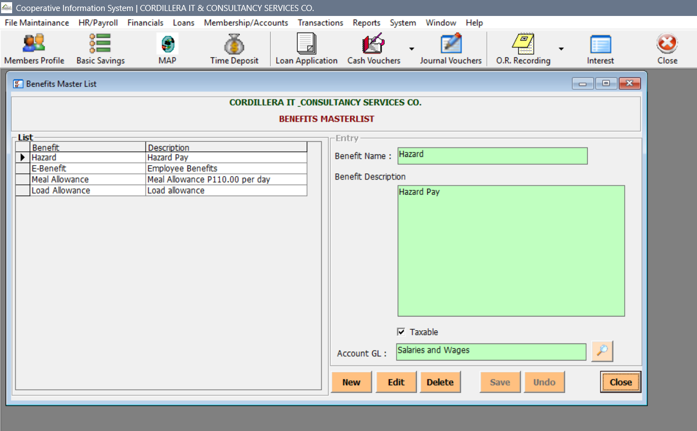

1. Salary Scale - This section standardizes salary rates across job roles, supporting monthly, semi-monthly, and daily computations.

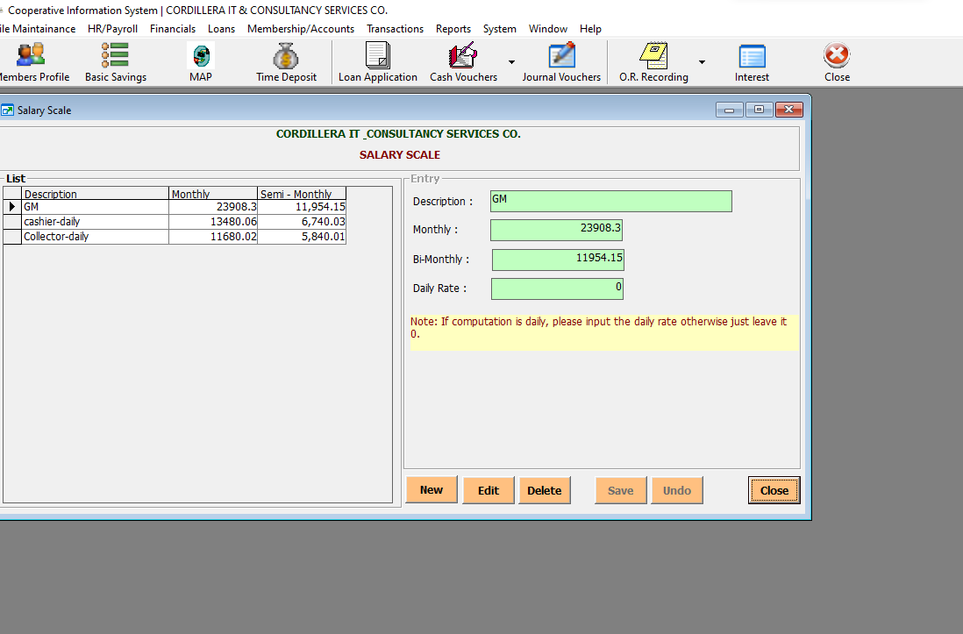

1. SSS Table - This section configures Social Security Service (SSS) contributions based on salary ranges, ensuring compliance with government-mandated rates.

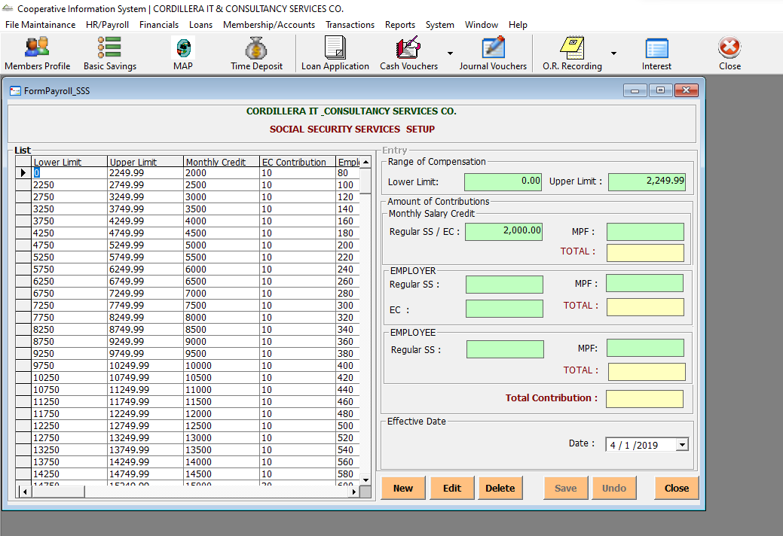

## Payroll / Employee Deductions

* This module allows HR personnel to assign and manage specific deductions for individual employees. This setup ensures accurate and individualized deduction tracking for payroll processing.
  + 1. In order to see Employee Deductions window, go to HR/Payroll Tab. Under Payroll, choose Employee deduction, user will be redirected to the window similar below.

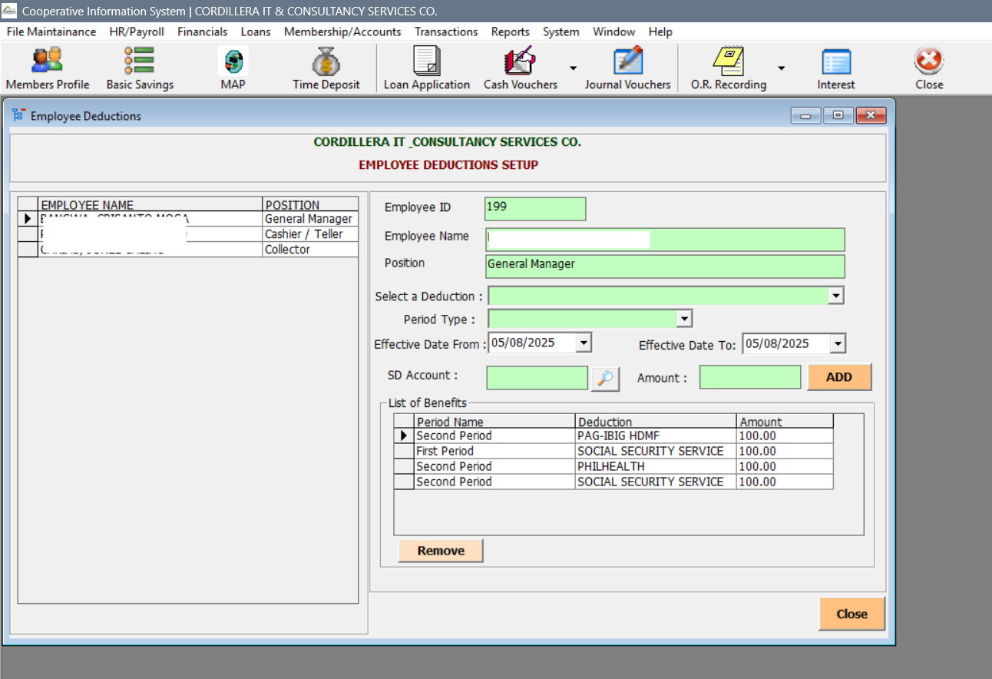

## Payroll / Employee Benefits

* This module is used for assigning and managing employee benefits within the System.
  + 1. In order to see Employee Deductions window, go to HR/Payroll Tab. Under Payroll, choose Employee Benefits, user will be redirected to the window similar below.

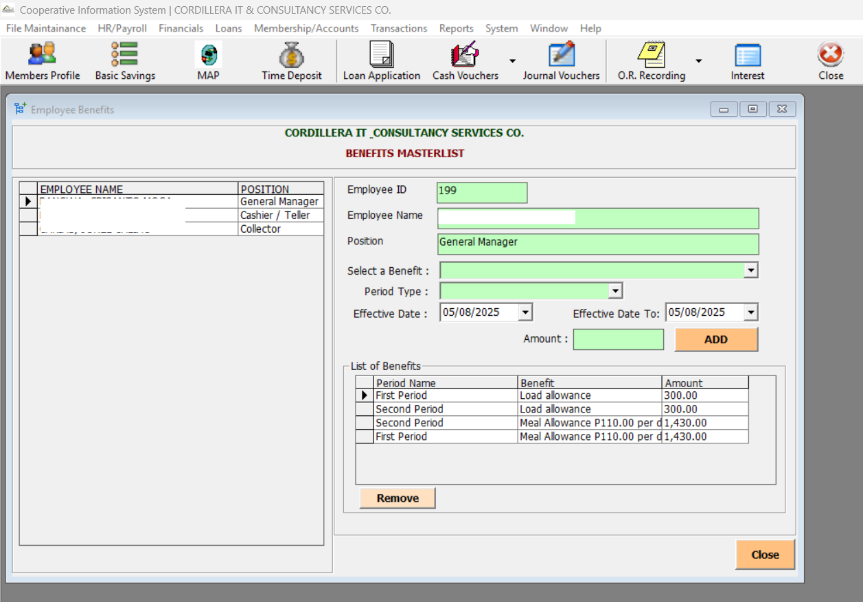

## Payroll / Payroll Entry

* This module handles detailed payroll processing for individual employees during a selected payroll period.
  + 1. In order to see Employee Deductions window, go to HR/Payroll Tab. Under Payroll, choose Payroll Entry, user will be redirected to the window similar below.

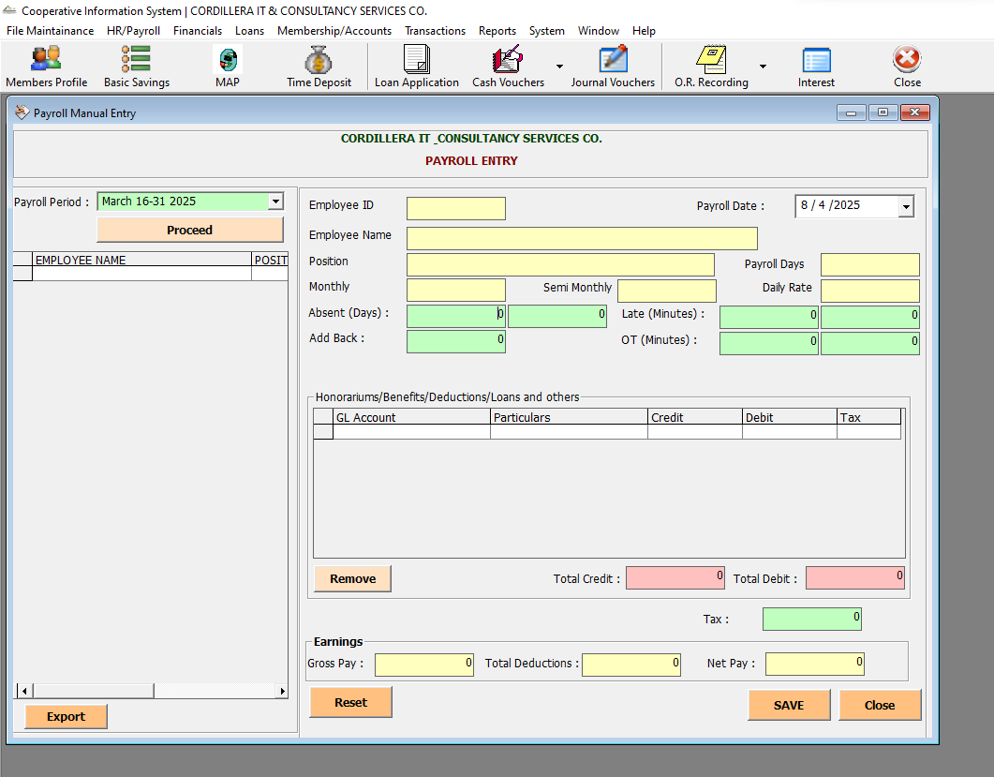

## Payroll / Post SL Payroll Deductions

* This module facilitates the posting of Salary Loan (SL) deductions from employee payrolls into cooperative accounts.
  + 1. In order to see Employee Deductions window, go to HR/Payroll Tab. Under Payroll, choose Post SL Payroll Deductions, user will be redirected to the window similar below.

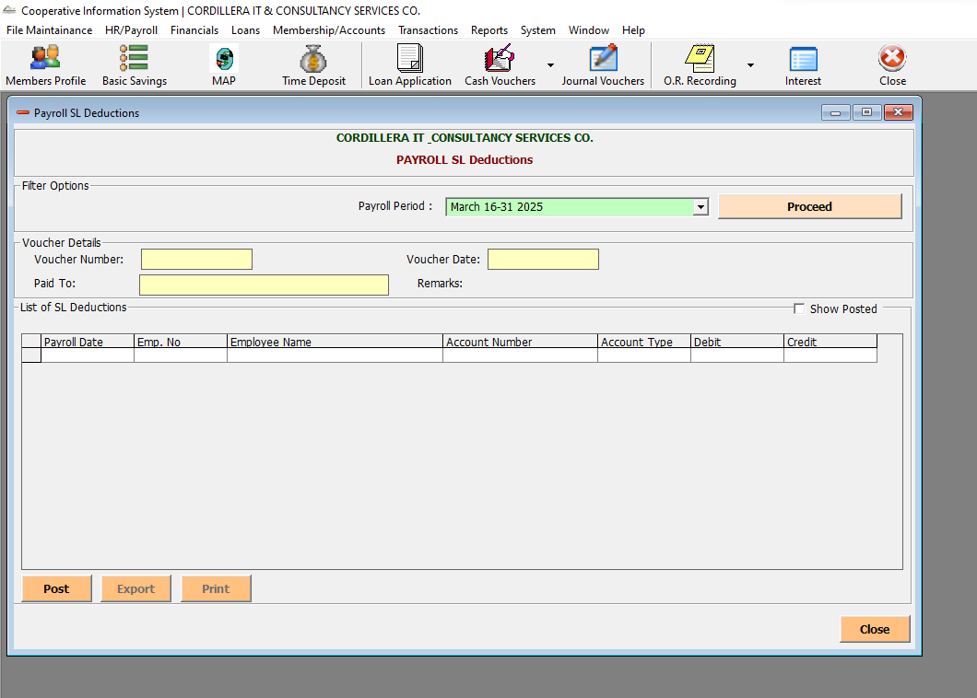

## Payroll / Payroll Reports

* Generate a consolidated report of employee payroll data for a selected period, useful for HR, accounting, and cooperative deductions.Generate and manage individual payslips for employees during a selected payroll period.
  + 1. In order to see Payroll Summary window, go to HR/Payroll Report. Under Payroll Report, choose Payroll Summary, user will be redirected to the window similar below.

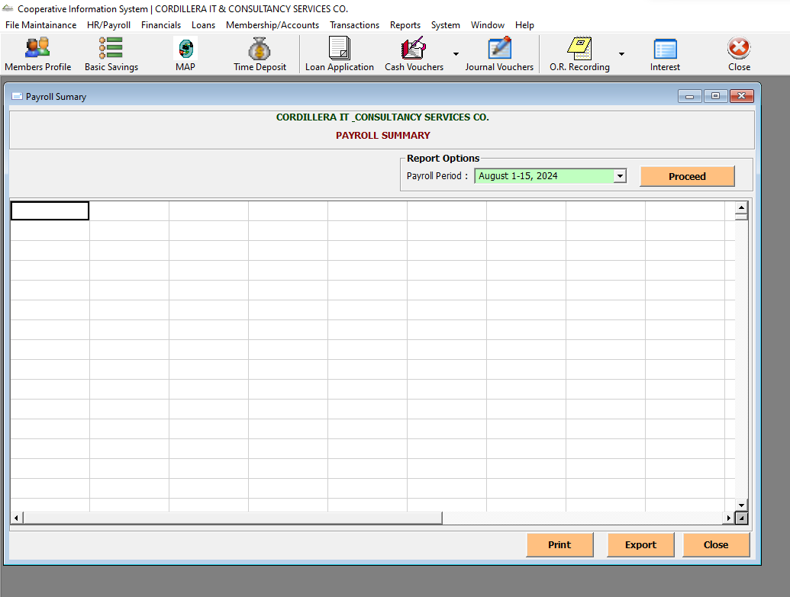

* + 1. In order to see Payroll Summary window, go to HR/Payroll Report. Under Payroll Report, choose Payroll Summary, user will be redirected to the window similar below.

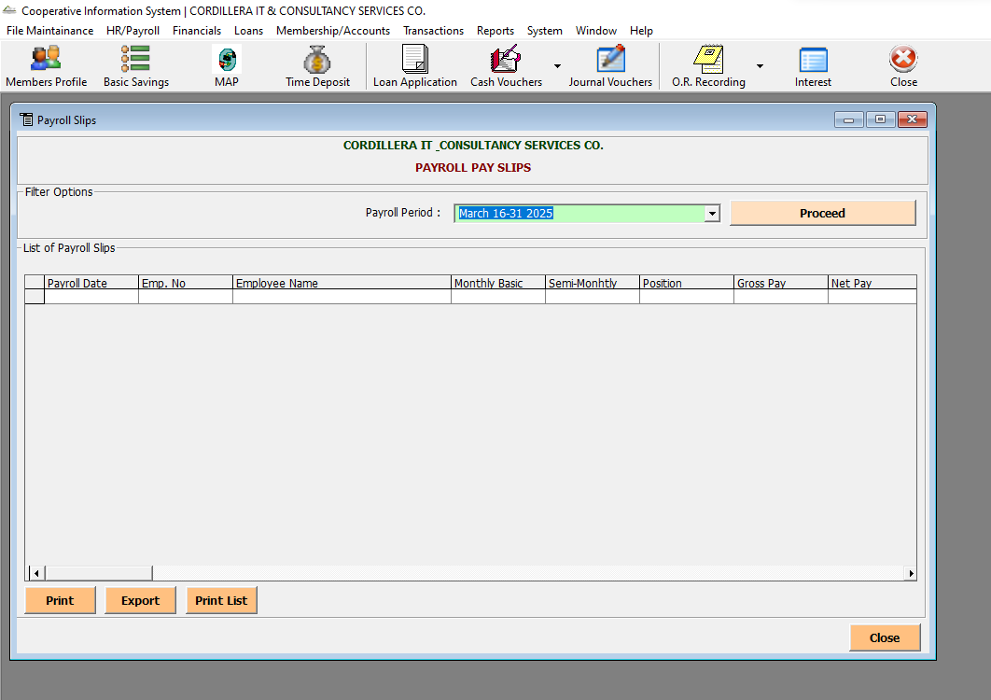

# Financials

* This module manages the cooperative’s financial setup, transactions, and reporting. It’s divided into five main areas: Setup, Reports, Assets, Chart of Accounts and Statements.

## Setup

* The Set-up contains two sub-modules namely Banks and Bank Accounts. Banks module is designed to register and manage partner banks that your cooperative transacts with. It serves as the foundational setup for linking financial operations—like deposits, withdrawals, and disbursements—to specific banking institutions. Bank Accounts module allows your cooperative to register and manage individual bank accounts tied to partner banks. It ensures accurate tracking of financial transactions, check issuance, and account balances.

1. To navigate to the Banks window, you can see the Financials Tab, then go to Setup and choose Banks.

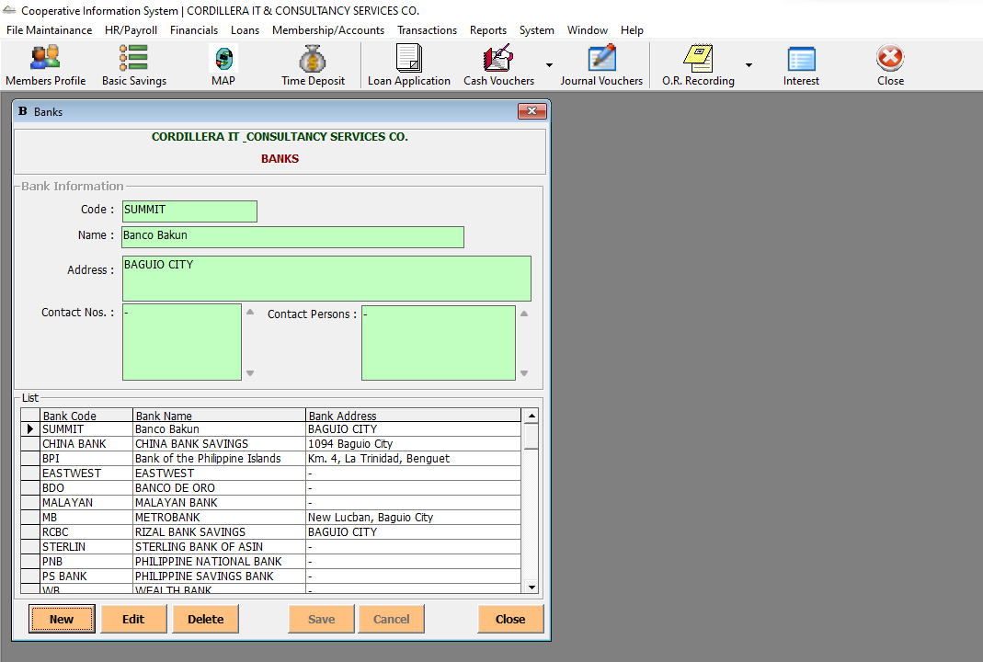

1. To navigate to the Banks window, you can see the Financials Tab, then go to Setup and choose Bank Accounts

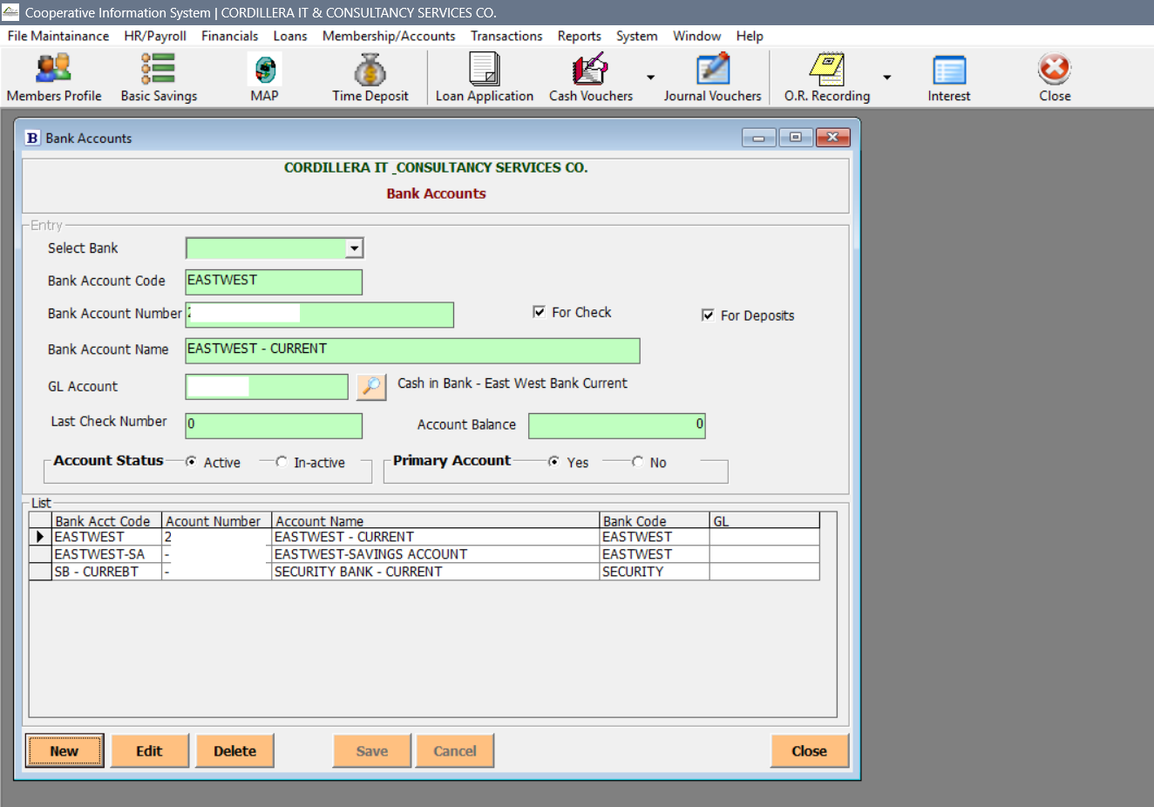

## Chart of Accounts

* This module defines and organizes all General Ledger (GL) accounts used for financial tracking, reporting, and compliance. It serves as the backbone of your accounting system.

1. To access Chart of Accounts window, go to Financial and select Chart of Accounts.

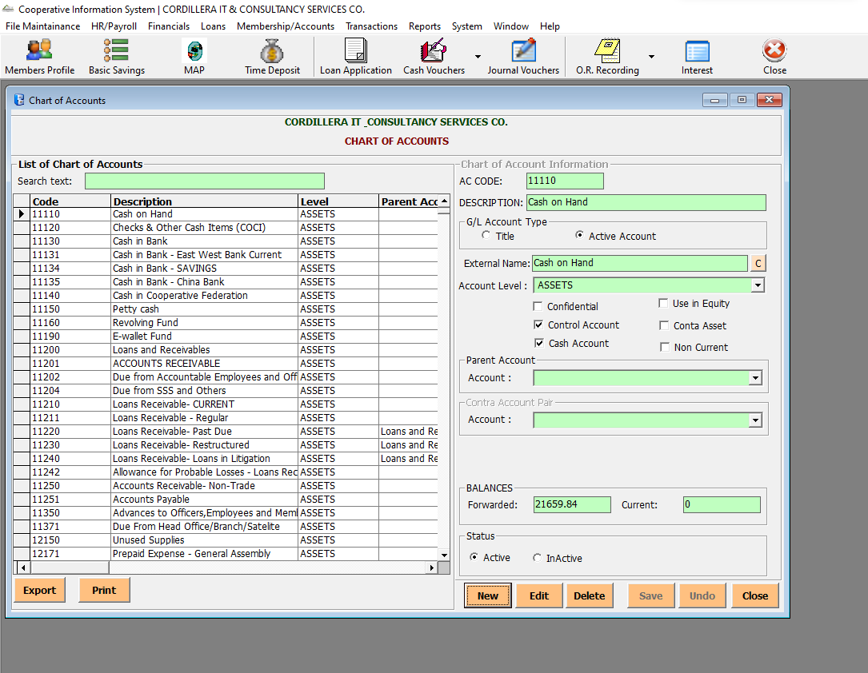

## Assets

* This module tracks fixed assets, their depreciation, and transaction schedules. It ensures accurate financial reporting and lifecycle monitoring.

1. To access Chart of Accounts window, go to Financial and select Assets.

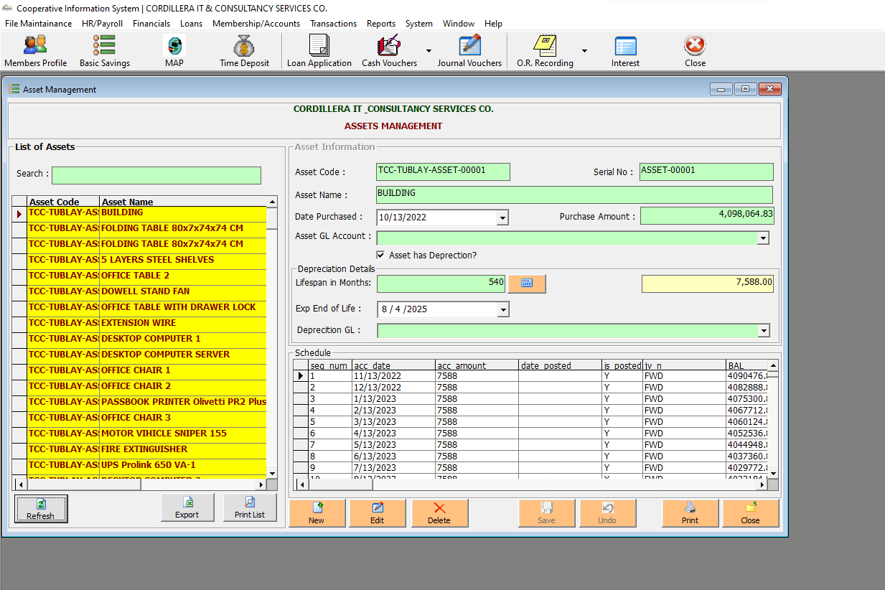

## Financial Reports

* This feature caters consolidated reports regarding financial transactions. Sub modules included are the following Reports: Cash Receipts, List of Cash Voucher, Sales and Receivables, List of Check Disbursement, List of Memo, Cash Disbursement Summary, List of Disbursed Check, List of Bank Deposits, List of Bank Withdrawals, List of Journal Vouchers, Journal Voucher Summary, Depreciation Summary, Financial Statement, Income Statement, Trial Balance, General Ledger. To navigate each financial reports, user must click the Financials tab and under Financial Reports, user can choose what reports to check on the list.

1. Cash Receipts - This module generates a detailed report of all cash inflows for a selected period, helping track payments received and ensuring accurate financial reconciliation.

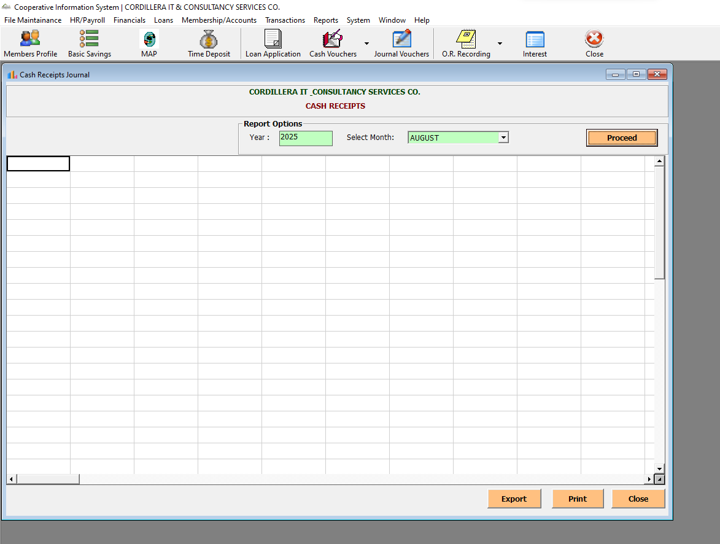

1. List of Cash Vouchers - This module generates a monthly report of all cash vouchers issued, helping track disbursements, validate transactions, and support audit processes.

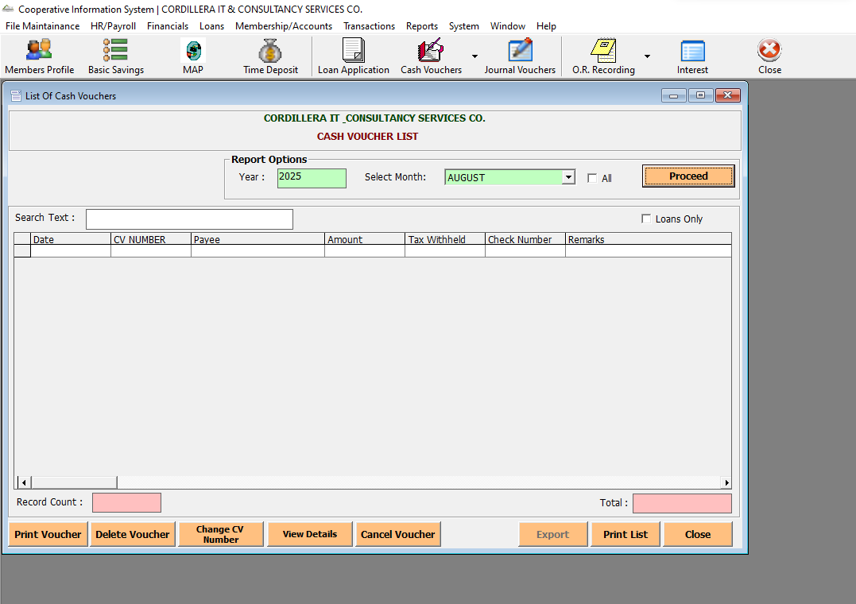

1. Sales and Receivables - This module provides a detailed view of cash vouchers and their corresponding receivable entries, helping reconcile income and ensure accurate ledger postings.

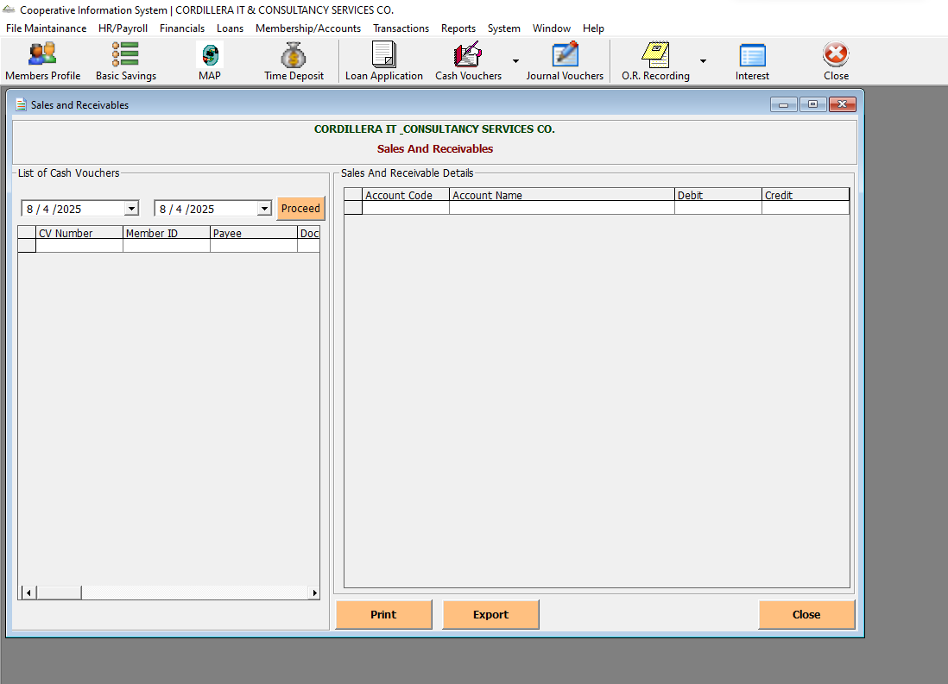

1. List of Check Disbursements - This module tracks all checks issued during a selected period, supporting financial transparency, audit readiness, and reconciliation with bank statements.

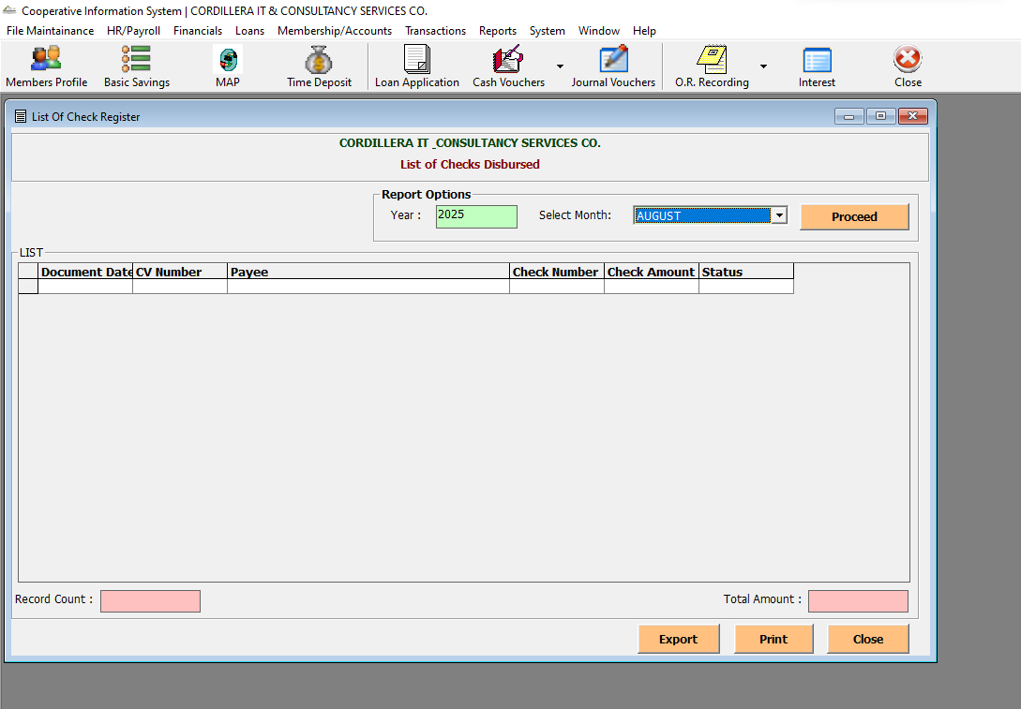

1. List of Memo - This module tracks all issued debit and credit memos for a selected period, helping reconcile adjustments, corrections, and internal transfers in the general ledger.

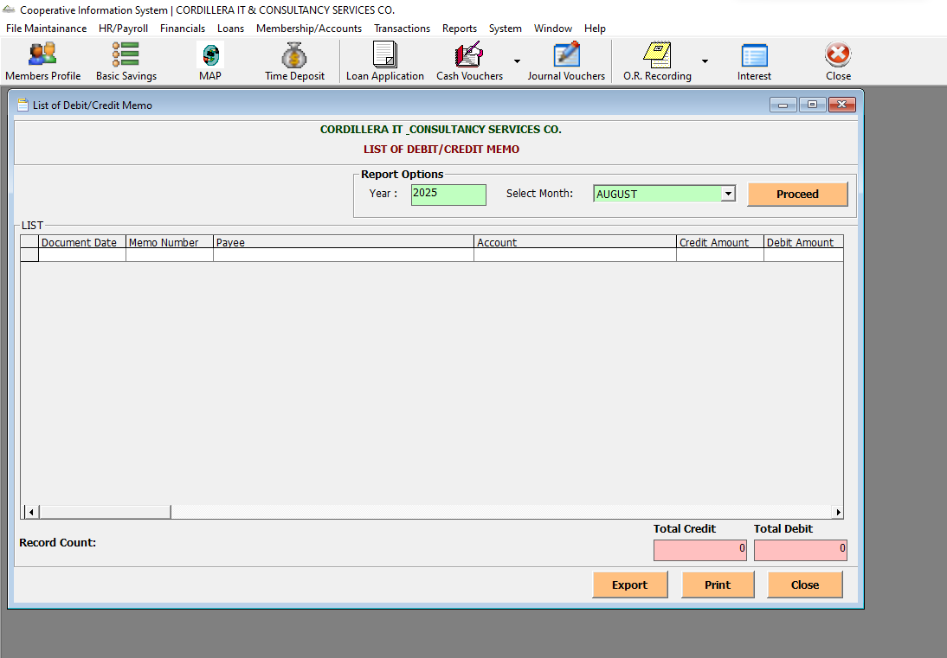

1. Cash Disbursement Summary - This module generates a summarized report of all cash disbursement vouchers issued within a selected period, helping monitor expenses and ensure proper financial documentation.

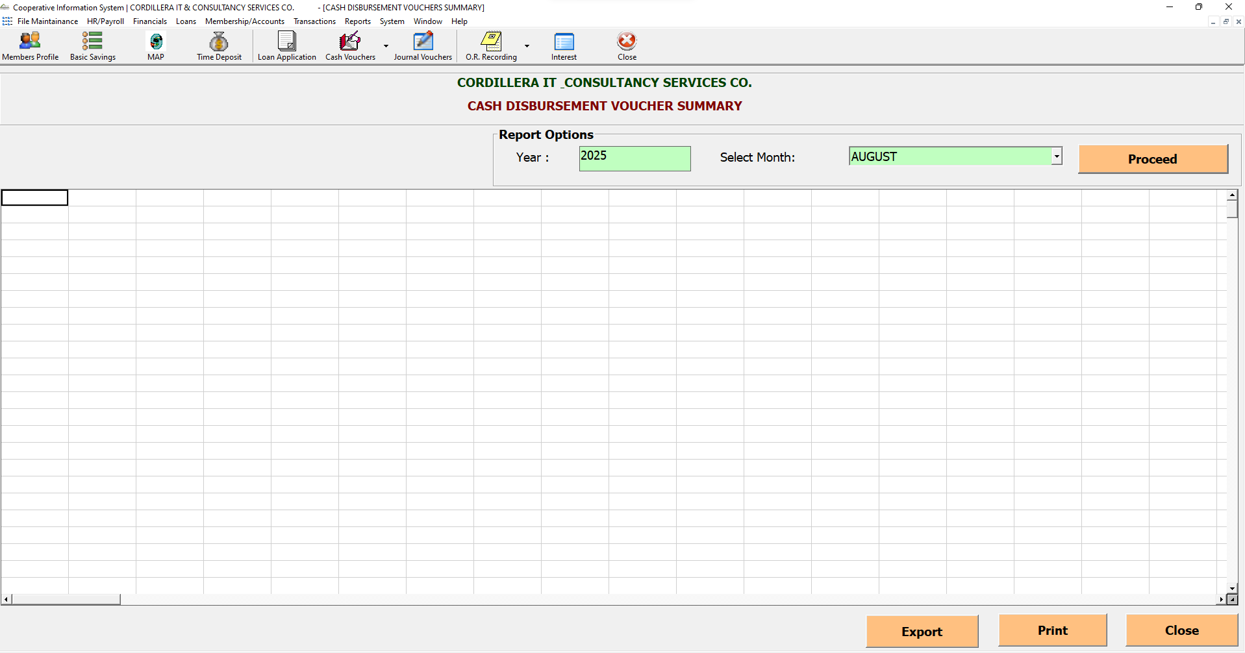

1. List of Disbursed Check - This module generates a summarized report of all cash disbursement vouchers issued within a selected period, helping monitor expenses and ensure proper financial documentation.

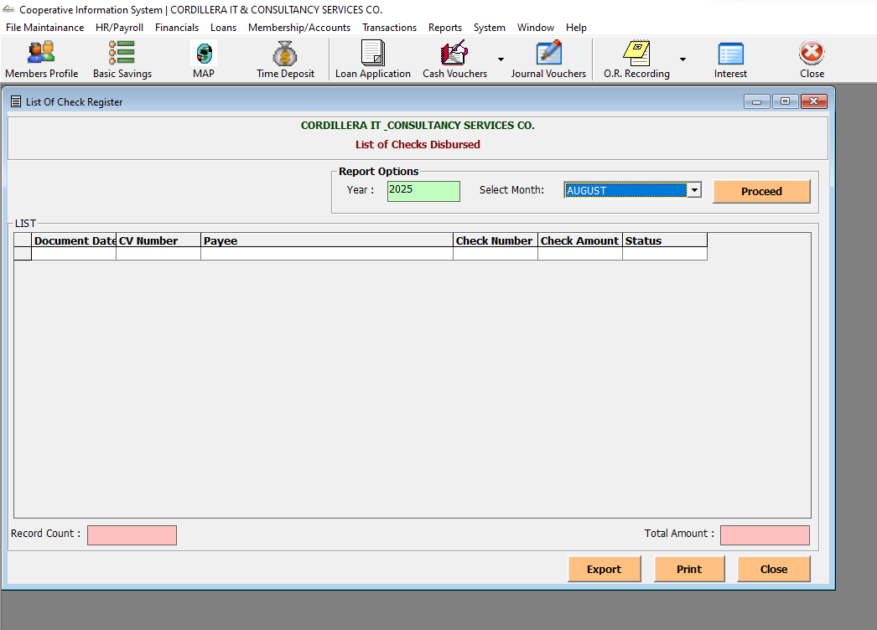

1. List of Bank Deposits - This module tracks all bank deposit transactions for a selected period, helping reconcile cash/check deposits with bank records and ensuring accurate financial reporting.

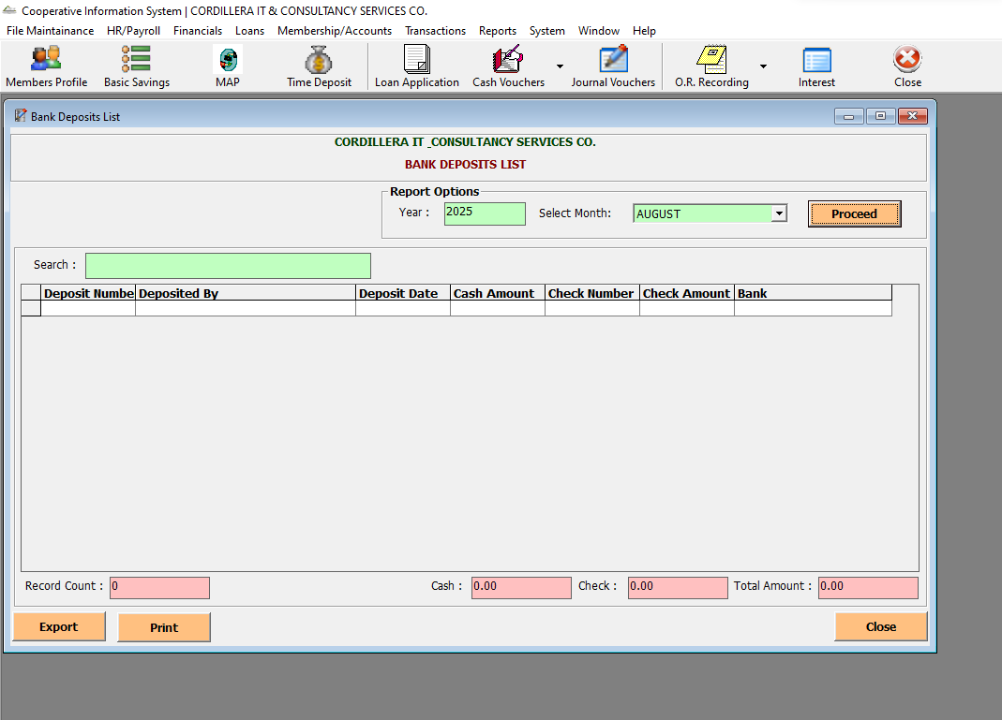

1. List of Bank Withdrawals - This module tracks all bank withdrawal transactions for a selected period, helping reconcile outgoing funds and maintain accurate financial records.

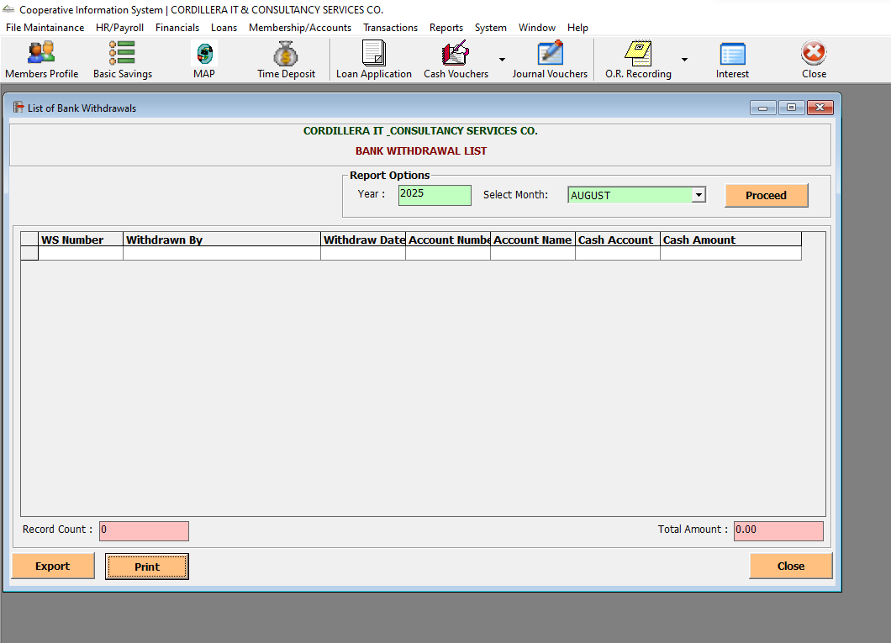

1. List of Journal Vouchers - Provides a chronological record of all manual accounting entries.

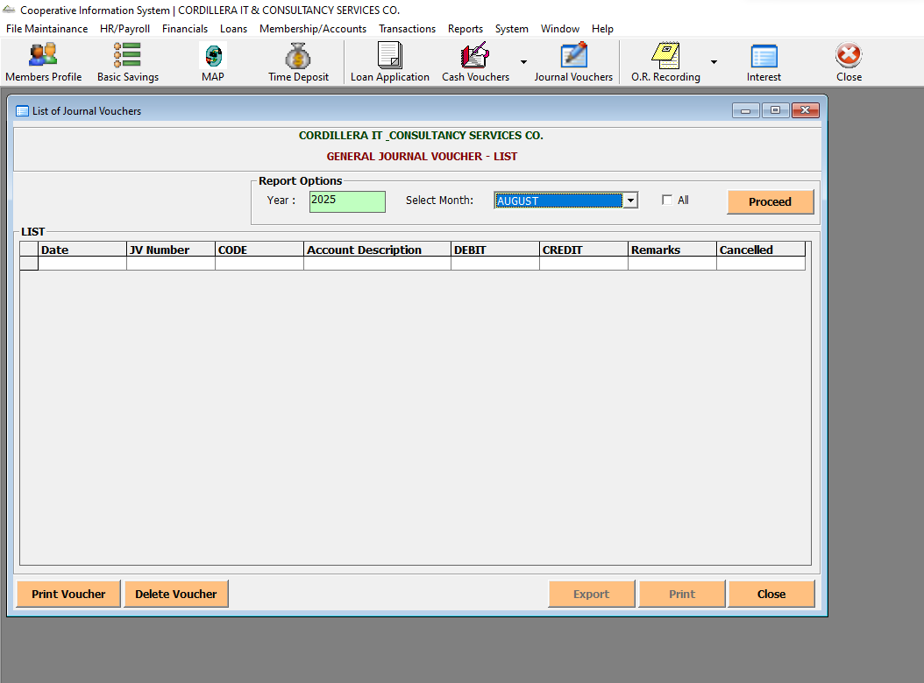

1. Journal Voucher Summary - Summarizes all journal vouchers for a selected period (e.g., August 2025).

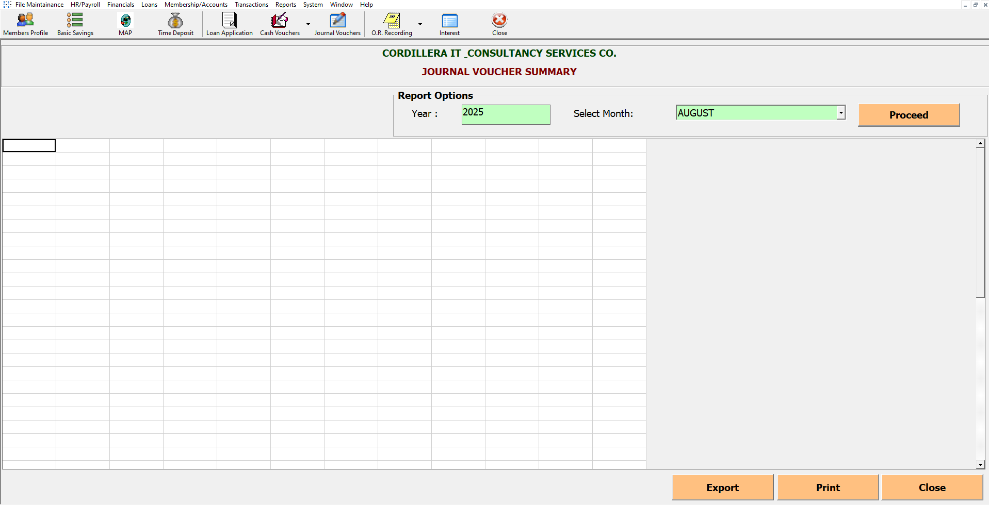

1. Depreciation Summary - Shows how fixed assets (e.g., buildings, equipment) lose value due to wear and tear or obsolescence.

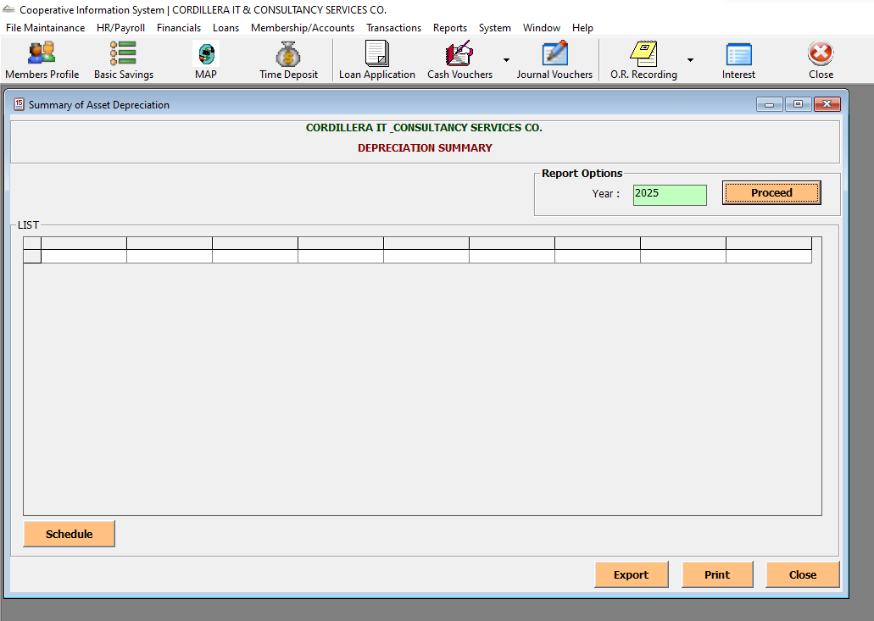

1. Financial Statement - The Financial Statement provides a comprehensive summary of a cooperative’s financial position, including assets, liabilities, income, and expenses.

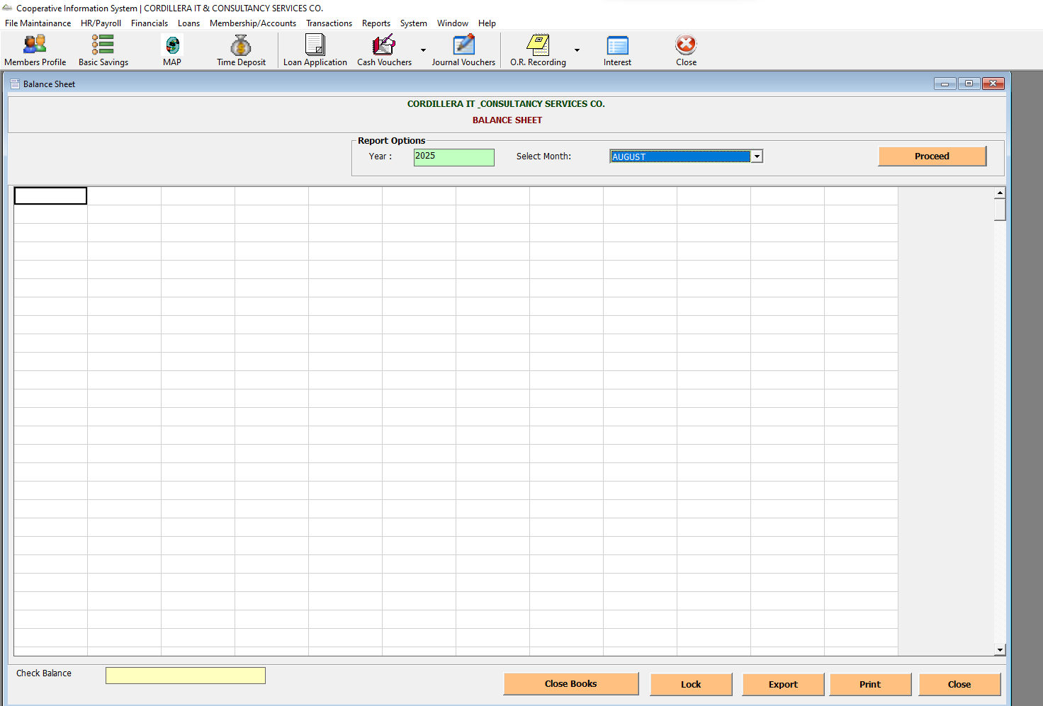

1. Income Statement - The Income Statement summarizes a cooperative’s revenues and expenses over a specific period, showing net profit or loss.

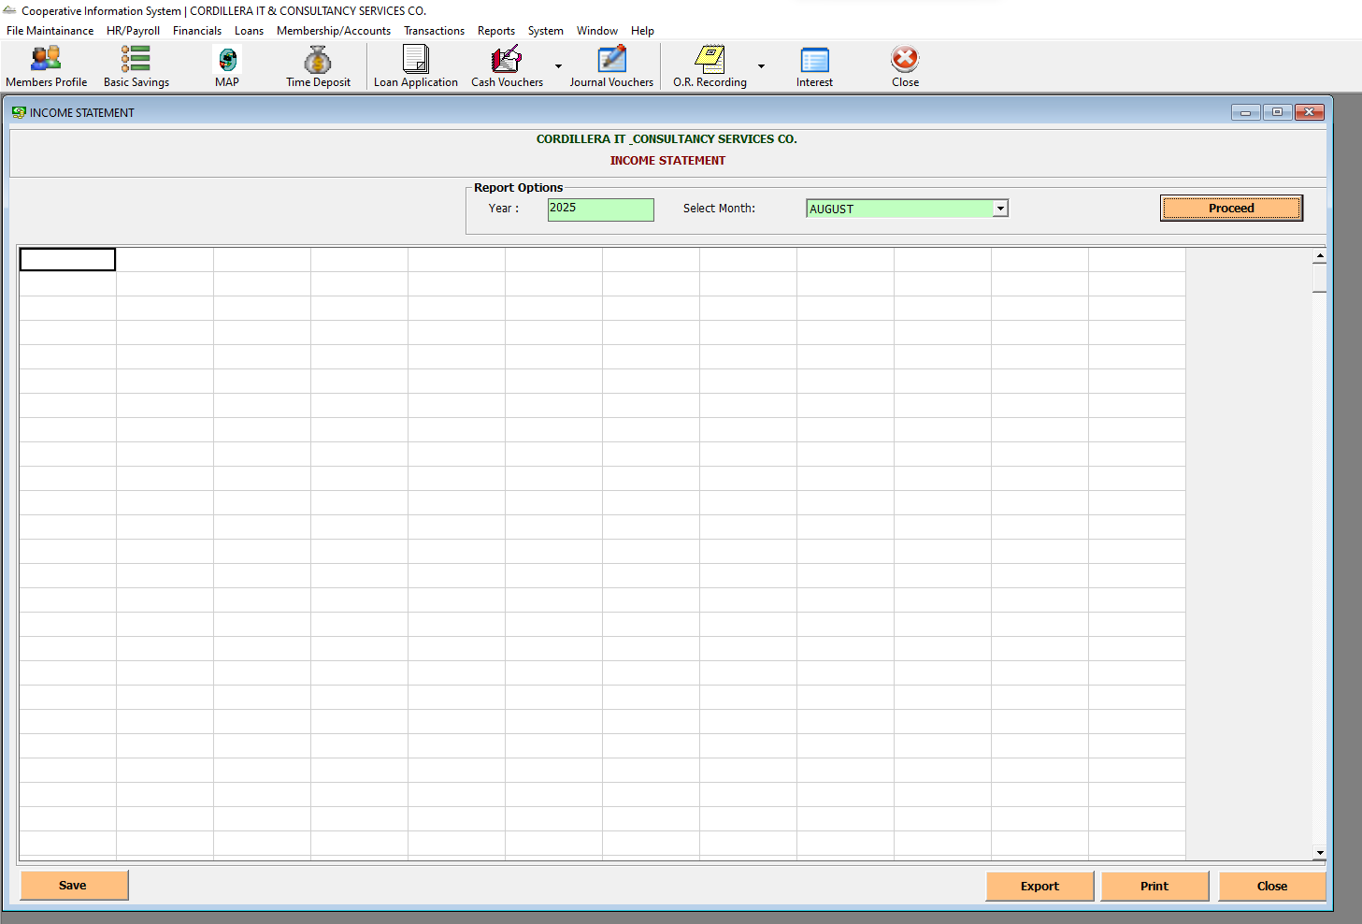

1. Trial Balance - The Trial Balance lists all ledger accounts with their debit and credit balances for a specific period, ensuring that total debits equal total credits.

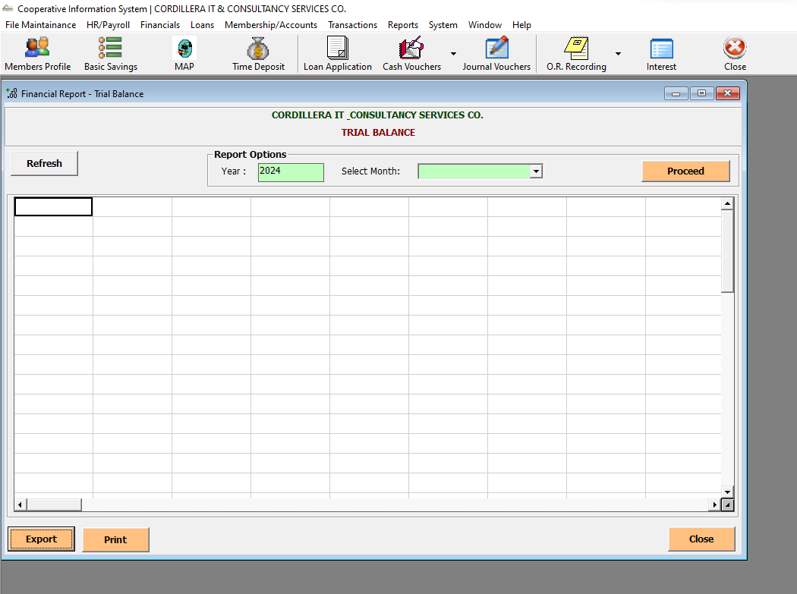

1. General Ledger - t supports accurate financial reporting by consolidating entries from sub-ledgers and journal vouchers.

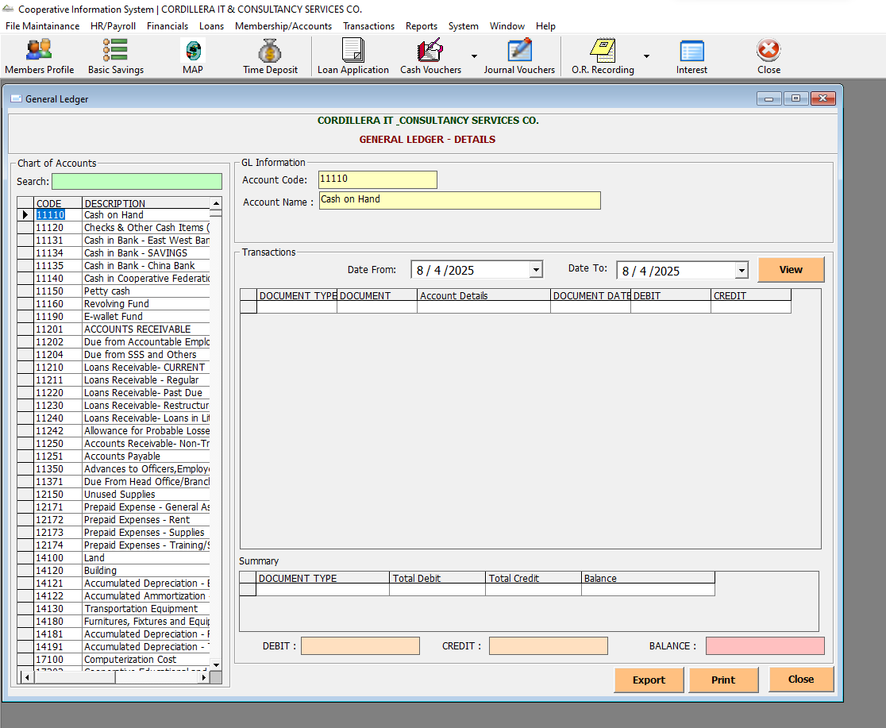

## Statement of Accounts

* To provide a member-centric financial overview, consolidating all relevant transactions—such as savings, loans, medical accounts, and other ledgers—into a structured, transparent format. User can navigate Statement of Accounts sub-modules in the Financials tab and clicking the Statement of Accounts.

1. GL Details - Shows how general ledger accounts are affected by member transactions

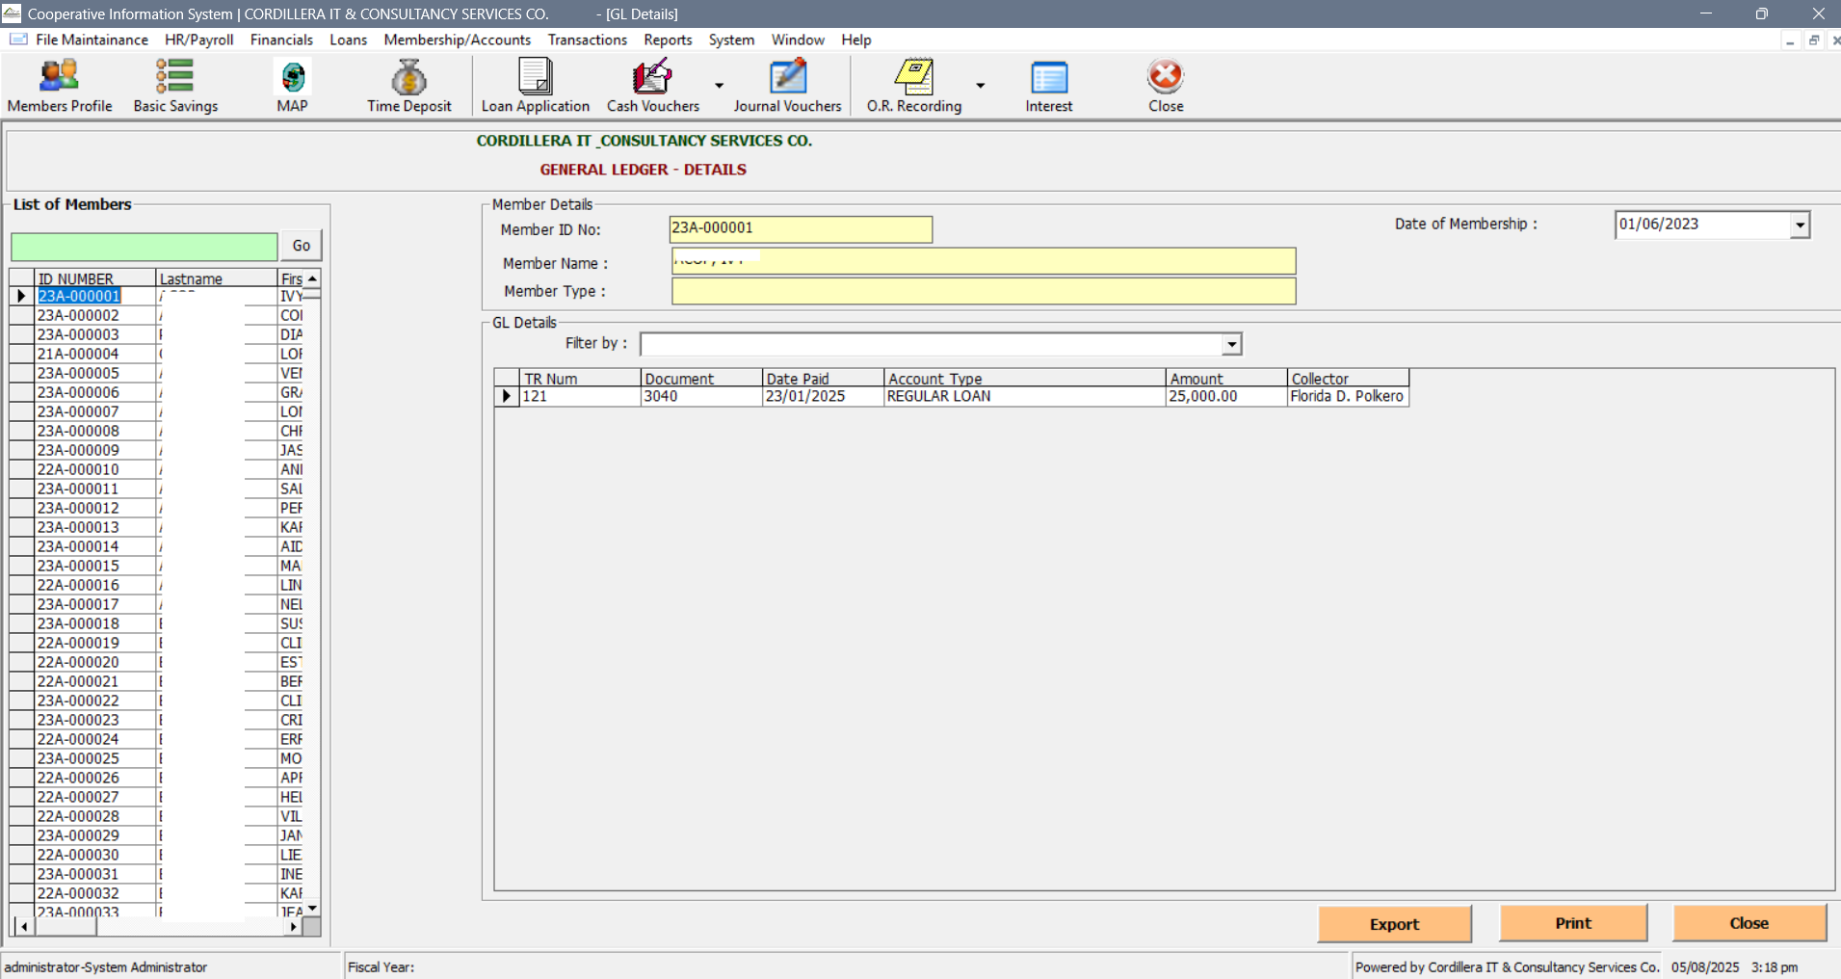

1. SL Details - Breaks down individual member activity per account type (e.g., Medical, Savings)

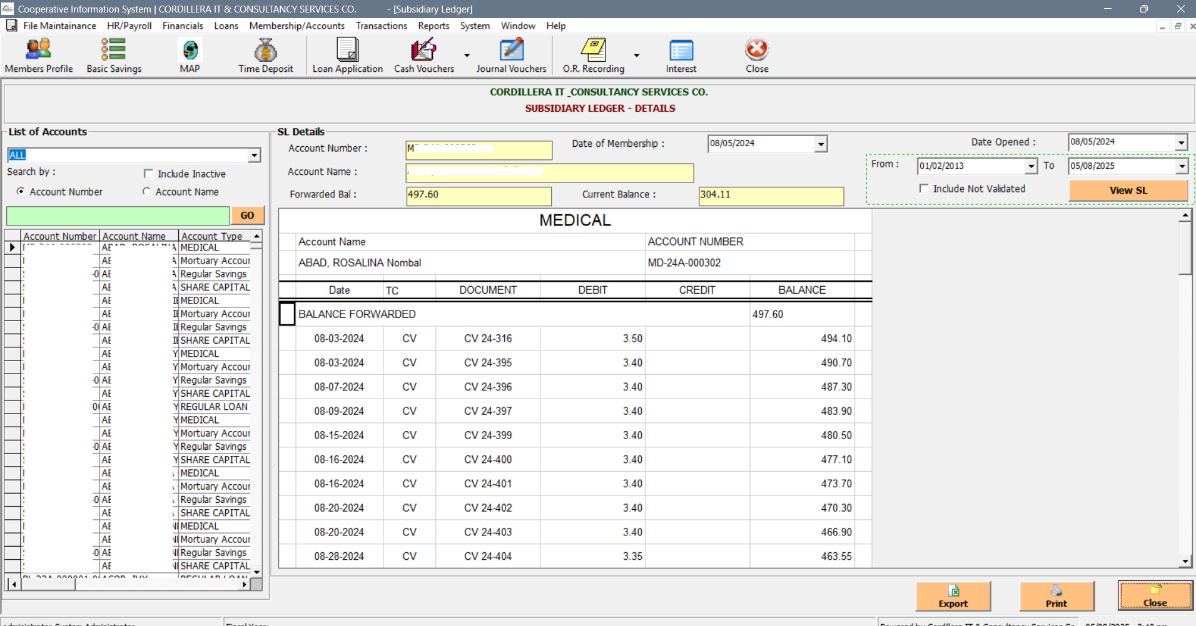

1. Loans Ledger - Tracks loan disbursements, amortizations, and outstanding balances

